










Thin dichroic specifications

Doc. No. ARGOS Tech Note 115
Issue 1.0
Date 29/03/2012

Prepared M. Bonaglia 29/03/2012
Name Date

TABLE OF CONTENTS

1 Scope 4
2 Applicable documents 4
3 Introduction 5
4 Product and Quantities 5
5 Substrate specifications 6
5.1 Geometry and material 6
5.2 Optical quality in reflection (First Surface - S1) 6
5.3 Optical quality in transmission (single-pass) 7
5.4 Other specifications 7
6 Coating specifications 9
7 Environment specifications 10
8 Shipping and Delivery 11
9 Contacts 12

LIST OF FIGURES

Figure 1: Top: footprints of the 3 LGS beams and of 9 natural objects on dichroic S1 optical area. The natural stars footprints are arranged at the edge of the scientific FoV that is transmitted by the dichroic. Bottom: footprints of the natural objects only on dichroic S2. The beams are shifted by 11mm in y direction. 8

Figure 2. Top view of the thin dichroic. The flat S1 surface is used to reflect the wavelengths <600nm towards the LGS WFS. S2 is wedged by 0.18° with respect to S1 and is shaped as a concave sphere. Wedge and sphere RoC have been enhanced to better show the arrangement. 9

Change Record

Issue | Date | Section/ Paragraph Affected | Reasons / Remarks | Name
1.0 | 29/03/2012 | All | Created | Bonaglia

Scope
The document defines the specifications of the thin dichroic, which reflects the laser light to the laser wavefront sensor and transmits the remaining light to the instrument focus.

Applicable documents

No. Title | Number & Issue
AD 1
AD 2
AD 3

Introduction

The requested optical elements are needed to transmit the science light (600-2450nm) toward the telescope instrumentation and to reflect the polarized laser light at 532nm and the unpolarized light at 589nm to the ARGOS wavefront sensors. The particular geometry of the telescope requests to polish two symmetric optical elements.
We are aiming on a procurement of the units, including coating, within one contract. But we accept offers either for procurement of the optics only, including reusable shipping boxes and delivery to a coating facility, or for coating only, including delivery to the contractor destination.
Therefore, we request from companies giving a combined offer to separate substrate processing and coating costs in their offer.

Product and Quantities

The following items are matter of procurement:

Item | Quantity | Description
001 | 2 | Glass blanks
002 | 2 | Processing of substrate according to specifications (the geometry is mirrored)
003 | 1 | Set of documentation for substrates
004 | 2 | Boxes for storage and transportation
005 | 2 | Processing of coating
006 | 1 | Set of documentation for coating

Substrate specifications

Geometry and material

Req. ID | Requirement description | Specification
REQ01 | Material | INFRASIL 302
REQ02 | Shape | Elliptical: (400x300)mm axes
REQ03 | Optical Area | Elliptical: (390x290)mm axes
REQ04 | Central Thickness | (25±1) mm
REQ05 | Wedge angle | (0.18±0.01)°
REQ06 | Wedge direction mark | Mark the edge by the minimum and maximum edge thickness with an arrow poining toward S1
 | First Surface (S1)
REQ07 | Surface shape | Flat
 | Second Surface (S2)
REQ08 | Surface shape | Spherical, concave
REQ9 | Sphere RoC | (110±10)m  See Figure 2.

Optical quality in reflection (First Surface - S1)

Req. ID | Requirement description | Specification
 |  | baseline | Goal
REQ30 | Average surface tilt on any circular patch of 13mm diameter in the optical area  (global tilt on the full optical area removed) | ≤26 nm/mm | ≤15 nm/mm
REQ31 | Surface error on any circular patch of 13mm diameter (tilt removed) in the optical area | ≤50 nm rms | ≤30 nm rms

Optical quality in transmission (single-pass)

Req. ID | Requirement description | Specification
 |  | baseline | Goal
REQ40 | Wavefront error on any circular patch of 85mm diameter (tilt removed) in the optical area. | ≤48 nm rms WFE | ≤30 nm rms WFE
REQ41 | Average tilt on any circular patch of 85mm diameter, after global tilt removal. | ≤9 nm/mm | ≤4 nm/mm

Other specifications

Req. ID | Requirement description | Specification
 |  | baseline | goal
REQ60 | Scratches and digs (S1 and S2) | DIN 3140 part 7 5/6x0.4; K2x0.025
REQ61 | Micro-Roughness (S1 and S2) | <2 nm rms |  | <1 nm rms

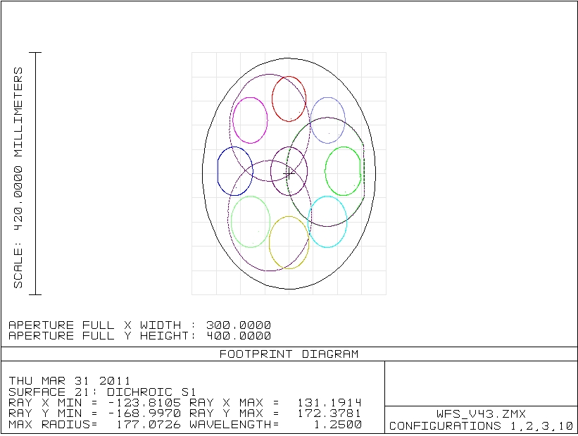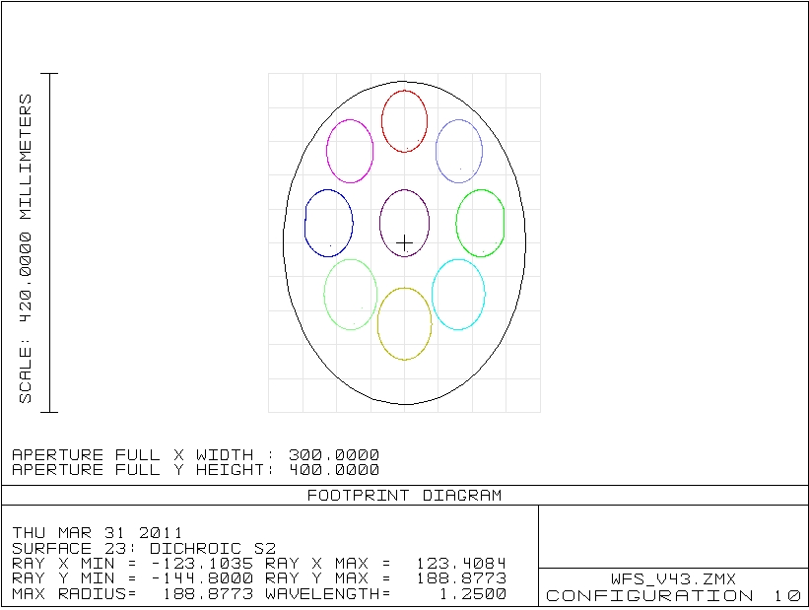

Figure 1: Top: footprints of the 3 LGS beams and of 9 natural objects on dichroic S1 optical area. The natural stars footprints are arranged at the edge of the scientific FoV that is transmitted by the dichroic. Bottom: footprints of the natural objects only on dichroic S2. The beams are shifted by 11mm in y direction.

Figure 2. Top view of the thin dichroic. The flat S1 surface is used to reflect the wavelengths <600nm towards the LGS WFS. S2 is wedged by 0.18° with respect to S1 and is shaped as a concave sphere. Wedge and sphere RoC have been enhanced to better show the arrangement.

Coating specifications

Req. ID | Requirement description | Specification
 | First Surface (S1) | baseline | goal
REQ70 | Reflected wavelengths | <600nm  (optimized for 532 and 589nm)
REQ71 | Reflectivity at 532nm (s-polarized) | >90% | >95%
REQ72 | Reflectivity at 589nm (unpolarized) | >90% | >95%
REQ73 | Transmission in 600-1000nm range | >90% | >95%
REQ74 | Transmission in 1000-2000nm range | >95% | >97%
REQ75 | Transmission in 2000-2450nm range | >98% | >99%
REQ76 | Reflectivity in 2000-2450nm range (to avoid dome thermal background reflection to instrumentation) | <2% | <1%
REQ77 | Coating defects area | <3mm² | <1mm²
REQ78 | Coating defects number on optical area | <20 | <7
 | Second Surface (S2) | baseline | goal
REQ80 | Transmission in 600-1000nm range | >90% | >95%
REQ81 | Transmission in 1000-2000nm range | >95% | >97%
REQ82 | Transmission in 2000-2450nm range | >98% | >99%
REQ83 | Reflectivity in 2000-2450nm range (to avoid dome thermal background reflection to instrumentation) | <2% | <1%

Environment specifications

Req. ID | Requirement description | Specification
REQ100 | Storage temperature range | -30 to 80°C
REQ101 | Working temperature range | -20 to 25°C
REQ102 | Humidity | up to 95%
REQ103 | Pressure | 650 to 1300mb
REQ104 | Operation angle | 40.5° wrt the normal to S1

Shipping and Delivery

The following points shall be considered during the manufacturing and delivery process:
- Review of final manufacturing drawings and the coating design by OAA

Req. ID | Requirement description | Specification
REQ120 | Packing and shipping | - Quote including packing and shipping into a coating protecting box out of plastic.  - No wooden boxes allowed.  - The items shall be packed in clean and sealed plastic bags, filled with dry nitrogen or shrink wrapped.  - All documentation shall be supplied in hardcopy with delivery and in electronic form (Microsoft Word or PDF) in advance of delivery.
REQ121 | Delivery Time | Estimate the delivery time at receipt of order
REQ122 | Acceptance | All specifications must be met. Various specifications cannot be traded.
REQ123 | Delivery Destination | Italy (or Germany), tbd
REQ124 | Number of units | Two (2)

Payment plan:

- 20% at receipt of glass blank(s)
- Any payment at order needs a bank guarantee.
- Balance after check of agreed specifications within 30 days (from receiving of goods).
- All payments by bank transfer within 30 days (from receiving of goods).

Contacts

Technical affairs:

Lorenzo Busoni
INAF-Osservatorio Astrofisico di Arcetri
Largo E. Fermi 5
50125 Firenze
Italy
Tel: +39.055.27.52.202
Fax: +39.055.27.52.292
e-mail: lbusoni@arcetri.astro.it

End of document

