ARGOS Commissioning:

Image wobble on LUCI1 Mask when locked on Pyramid

A test of the stability of the PSF on the Luci Mask was performed, since during observations we recognized a drift of the object location.

The test was performed in closed dome with the Argos calibration unit as source. Following setting was used:

-Luci1 N30 field stop in the FPU

-FeII / Clear filters

-3.75 Camera

-3s integration time

-Argos Cal unit in, white light source on (intensity on Luci adjusted to25000 peak flux in closed loop)

-AO loop closed high order and TT on the pyramid sensor.

-some background light on in the dome, to allow the mask to be visible.

That’s how the image then looks like:

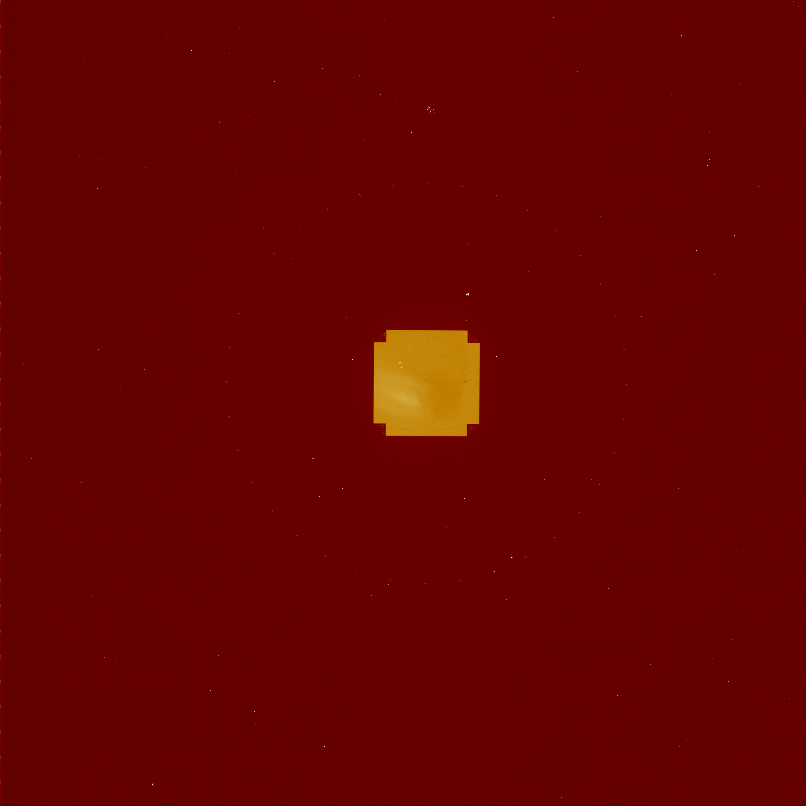



Cal unit source

Mask position detection

Figure 1: closer view of the field stop with the ARGOS cal unit on. Blue box: area used to pre detect the Mask Y position. Yellow box: area for the Mask X position detection. Small holes in the mask: used for measuring the exact Mask position.

Following test was performed:

-Rotation of LUCI1 in 20° steps while keeping the AO loop closed on the pyramid. This ensures a good PSF all over the test.

-From this test we can detect the mask position with centroiding the small alignment holes in the corner of the mask. (a pre-detection of the crude mask position was done with detecting the mask borders in X and Y, since the flexure loop could not be closed when looking to Zenith with the telescope) (we could repeat with fitting a gaussian to the PSF as well)

-measuring then the location of the Argos cal unit PSF on the detector with a centroid, we get the motion of the PSF on the Mask. The outcome is shown in the following plots:

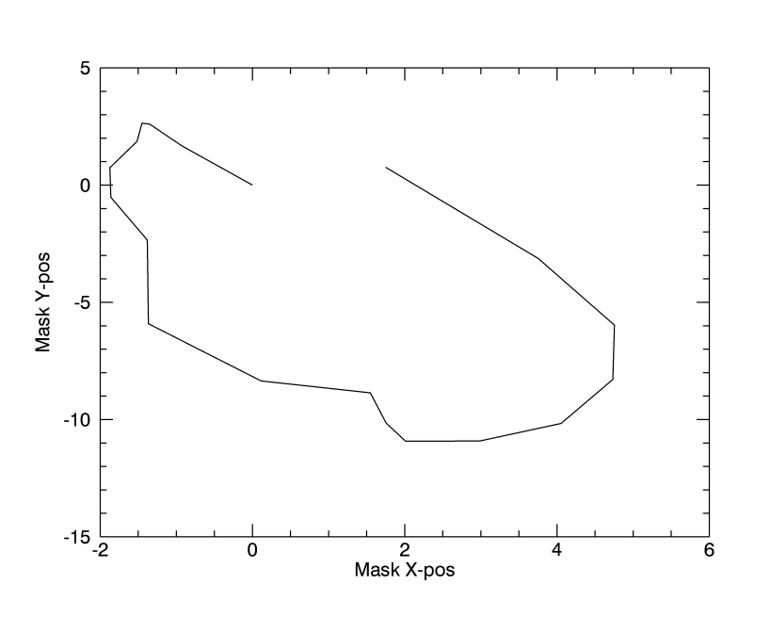

Figure 2: position of the mask image on the detector when rotating Luci by 360°

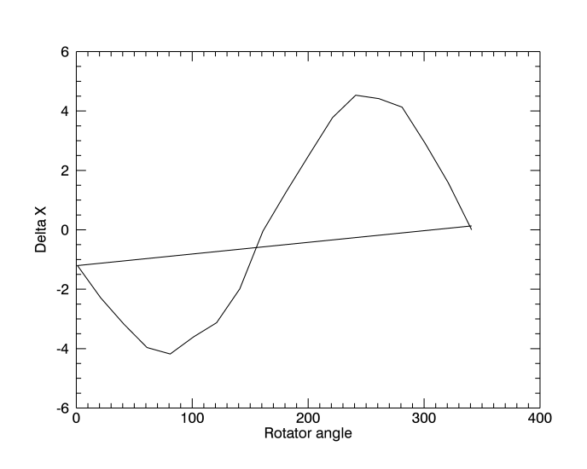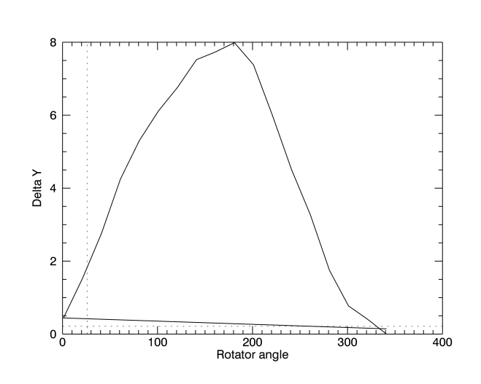

Figure 3: difference between PSF position and Mask position.

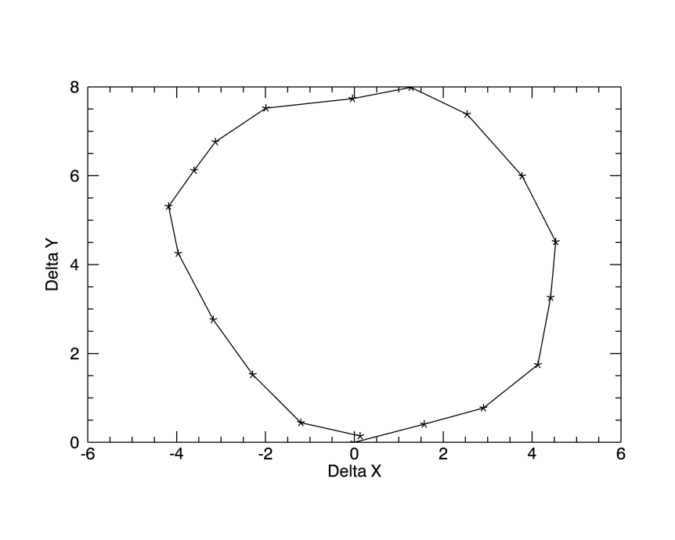

Figure 4: XY plot of the PSF wobble on the mask. Units are pixel.

Conclusion:

The PSF location on the mask wobbles by ~1 arcsec while LUCI1 rotates 360°. Most probably the figure of the wobble is a circle and might be the K-mirror misalignment to the rotator axis inside the FLAO. This wobble is by far too large for useful MOS or LS observation

Actions:

1. Re measure this wobble with high accuracy in Luci1 and luci2 with the AO locked on the pyramid. One should close the passive flexure compensation for this measurement to decrease the mask image motion for better precision. Multiple turns should be done to prove repeatability.
2. Do the same measurement when being locked on the APD. (could we be doing truth sensing to keep the PSF in good shape?)
3. Compensation of this wobble needs to be performed. Where is tbd.
4. A regular check needs to be performed after any FLAO intervention

Data of that measurement can be found in:

|  |  |
| --- | --- |
| Rotatorangle | Filename |
| 341 | luci1.20161025.0275.fits |
| 321 | 276 |
| 301 | 277 |
| 281 | 278 |
| 261 | 279 |
| 241 | 280 |
| 221 | 281 |
| 201 | 282 |
| 181 | 283 |
| 161 | 284 |
| 141 | 285 |
| 121 | 286 |
| 101 | 287 |
| 81 | 288 |
| 61 | 289 |
| 41 | 290 |
| 21 | 291 |
| 01 | 292 |
| 341 | 293 |

FLAO stage drift during the LUCI rotation

|  |  |  |  |
| --- | --- | --- | --- |
| Rotator angle | ARGOS snapshot | X stage (mm) | Y stage (mm) |
| 341 | 20161025_083341 |  |  |
| 321 | 20161025_083513 | -71.94 | -47.67 |
| 301 | 20161025_083633 | -71.93 | -47.65 |
| 281 | 20161025_083739 | -71.91 | -47.63 |
| 261 | 20161025_083855 |  |  |
| 241 | 20161025_084037 | -71.83 | -47.64 |
| 221 | 20161025_084141 | -71.78 | -47.66 |
| 201 | 20161025_084239 | -71.76 | -47.68 |
| 181 | 20161025_084350 | -71.74 | -47.71 |
| 161 | 20161025_084548 |  | -47.78 |
| 141 | 20161025_084801 | -71.75 | -47.85 |
| 121 | 20161025_084909 | -71.76 | -47.88 |
| 101 | 20161025_085024 | -71.77 | -47.89 |
| 81 | 20161025_085120 | -71.80 | -47.90 |
| 61 | 20161025_085232 | -71.83 | -47.88 |
| 41 | 20161025_085342 | -71.90 | -47.87 |
| 21 | 20161025_085438 | -71.93 | -47.85 |
| 01 | 20161025_085600 | -71.94 | -47.81 |
| 341 | 20161025_085742 | -71.95 | -47.75 |

The FLAO stages were operated in Motor Off - Brake On, so there was no attempt to actively keep the position. When motor brakes are on, the stifness of the stages allow a certain drift of the board that is measured by the absolute encoders. During the 360deg rotation, the PtV of the stages’ drift is about 0.20-0.25mm corresponding to about 350-400 mas.