**ARGOS Objects May 2017**

INAF targets

|  |  |  |  |
| --- | --- | --- | --- |
|  | Name | Ra | Dec |
| Fiorentino | NGC6535 | 18:03:50.51 | -00:17:51.5 |
|  | GLIMPSE-C01 | 18:48:49.7 | -01:29:50 |
| LaFranca |  | 13:25:01.25 | +36:26:14.16 |
| Rampazzo | KIG488 | 11:35:41.7 | +73:27:07 |
|  | KIG570 | 13:04:41.9 | +02:57:49 |
|  | KIG614 | 14:10:42.1 | +21:57:24 |
|  | KIG697 | 15:42:34.3 | +02:00:52 |
| Rossi | HG090323 | 12:42:50.28 | +17:03:11.9 |
| Tomassella | SN 2012A | 10:25:07.39 | +17:09:14.6 |
| Vanzella | JD1/JD2 | 06:47:55.731 | +70:14:35.76 |
|  |  |  |  |
|  |  |  |  |

MPIA Targets

|  |  |  |  |
| --- | --- | --- | --- |
| Sesar /testa | NGC5466 | 14:05:30.56 | +28:32:07.63 |
| Georgiev | NGC4449 | 12:28:11.12 | +44:05:36.8 |
|  | NGC2903 | 09:32:10.11 | +21:30:03.0 |
|  | NGC6384 | 17 32 24.32 | +07 03 37.7 |
|  | NGC6946 | 20 34 52.33 | +60 09 13.2 |
|  | NGC5195 | 13:29:59.59 | +47:15:58.1 |
|  | NGC4605 | 12:39:59.38 | +61:36:33.1 |
|  | NGC5238 | 13:34:42.51 | +51:36:49.2 |
|  | NGC6207 | 16:43:03.75 | +36:49:56.7 |
|  | NGC6239 | 16:50:05.03 | +42:44:23.4 |
|  | UGC11466 | 19:42:58.75 | +45:17:54.0 |
|  | UGC11583 | 20:30:15.39 | +60:26:25. |
| van der Wel, | LEGA-C 1 | 10:00:31.06 | +02:21:11.2 |
| Ajan Bik | W51 | 19:23 :2.427 | +14:16:25.980 |

MPE Targets

|  |  |  |  |
| --- | --- | --- | --- |
| Contursi | EGS24985 | 14:19:26.663 | +52:51:16.980 |
| Förster-Schreiber | zc406690 | 09:58:59.128 | +02:05:04.25 |
| Rabien | SDSS1527 | 15:27:45.82 | +06:52:33.6 |
|  | SDSSJ1110 | 11:10:17.69 | +64:59:48.2 |
|  | SDSSJ1038b | 10:38:43.6 | +48:49:18 |
| Rabien/ Cresci? | SDSSJ1985 | 19:58:35.65 | +59:50:53.6 |
|  | SDSS J1723 | 17:20:13.50 | +35:36:03.83 |

UA Targets

|  |  |  |  |
| --- | --- | --- | --- |
| Frye | PLCKG165 | 11:27:14.60 | +42:28:25 |
| Vestergaard | NGC2617 | 08:35:38.8 | −04:05:17.9 |
|  | MRK50 | 12:23:24.15 | +02: 40:44.15 |
| Mainali / Stark | EGSY-200853266 | 14:20:08.50 | 52:53:26.6 |
|  |  |  |  |

Virginia Targets

|  |  |  |  |
| --- | --- | --- | --- |
| Whittle | wise1046-02 | -02:50:30.6 | 10:46:32.8 |
|  | wise0943+03 | +03: 03:23.1 | 09:43:52.95 |
|  |  |  |  |
|  |  |  |  |
|  |  |  |  |
|  |  |  |  |

Photo standards

|  |  |  |  |
| --- | --- | --- | --- |
| Georgiev | P035-R | 08:25:43.8 | 73:01:18 |
|  | P091-D | 09:42:58.7 | 59:03:43 |
|  | P212-C | 10:06:29.0 | 41:01:26 |
|  | P550-C | 10:33:51.8 | 04:49:05 |
|  | S852-C | 09:41:35.8 | 00:33:12 |
|  | P545-C | 08:29:25.1 | 05:56:08 |
|  | S842-E | 06:22:43.7 | -00:36:30 |
|  | S840-F | 05:42:32.1 | 00:09:04 |
|  | P247-U | 03:32:03.0 | 37:20:40 |
|  | P161-D | 07:00:52.0 | 48:29:24 |
|  | P309-U | 07:30:34.5 | 29:51:12 |
|  | S791-C | 13:17:29.6 | -05:32:37 |
|  | S860-D | 12:21:39.3 | -00:07:13 |
|  | P266-C | 12:14:25.4 | 35:35:55 |
|  | P064-D | 12:13:12.0 | 64:28:56 |
|  | P041-C | 14:51:57.9 | 71:43:13 |
|  | P133-C | 13:58:40.2 | 52:06:24 |
|  | P272-D | 14:58:33.1 | 37:08:33 |
|  | P177-D | 15:59:13.6 | 47:36:40 |
|  | P138-C | 17:13:44.5 | 54:33:21 |
|  | P182-E | 18:39:33.7 | 49:05:38 |
|  | P330-E | 16:31:33.6 | 30:08:48 |
|  | P499-E | 14:07:33.9 | 12:23:51 |
|  | S867-V | 14:40:58.0 | -00:27:47 |
|  | S870-T | 15:39:03.5 | 00:14:54 |
|  | P565-C | 16:26:42.7 | 05:52:20 |
|  | S875-C | 17:27:22.2 | -00:19:25 |

|  |  |  |  |
| --- | --- | --- | --- |
| Southern stars | 1180-0209917 | 08:59:23.93 | +28:00:37.4 |
|  | 1180-0227987 | 10:59:28.78 | +28:03:51.7 |
|  | 1181-0239678 | 12:59:22.78 | +28:08:00.2 |
|  | 1181-0262285 | 15:00:17.46 | +28:10:37.1 |
|  | 1181-0292322 | 17:00:48.45 | +28:10:12.2 |
|  | 1181-0367331 | 19:00:27.71 | +28:11:16.4 |
|  | 1181-0644849 | 21:00:18.14 | +28:10:36.1 |
|  |  |  |  |
| Northern stars | 1283-0211755 | 10:00:36.85 | +38:18:30.1 |
|  | 1283-0233897 | 12:01:21.16 | +38:20:34.9 |
|  | 1280-0267072 | 14:01:08.93 | +38:04:51.9 |
|  | 1281-0297639 | 16:01:41.50 | +38:10:25.1 |
|  | 1281-0332354 | 18:01:27.32 | +38:09:39.1 |
|  | 1281-0458113 | 20:01:33.55 | +38:10:40.0 |
|  | 1281-0604238 | 22:01:37.06 | +38:10:13.7 |

INAF

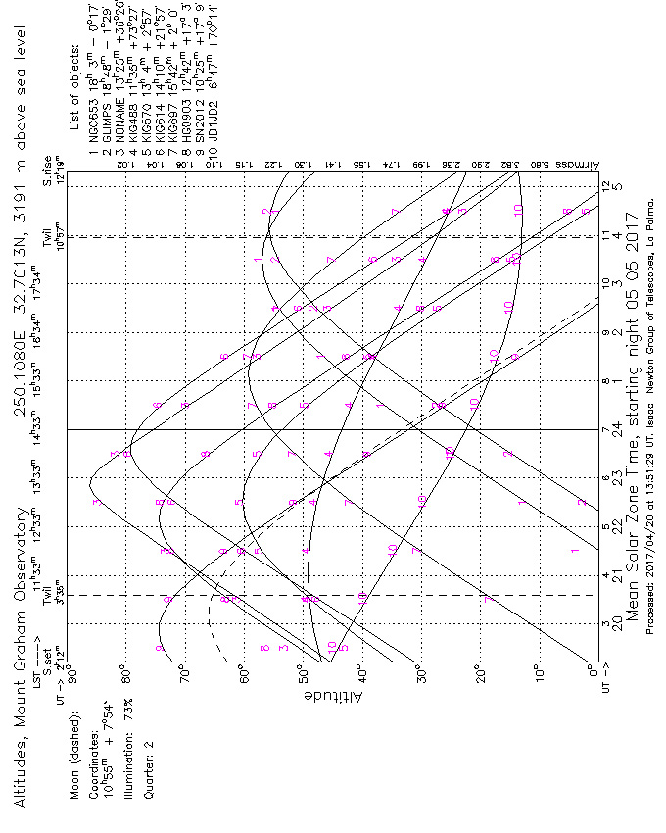

MPIA

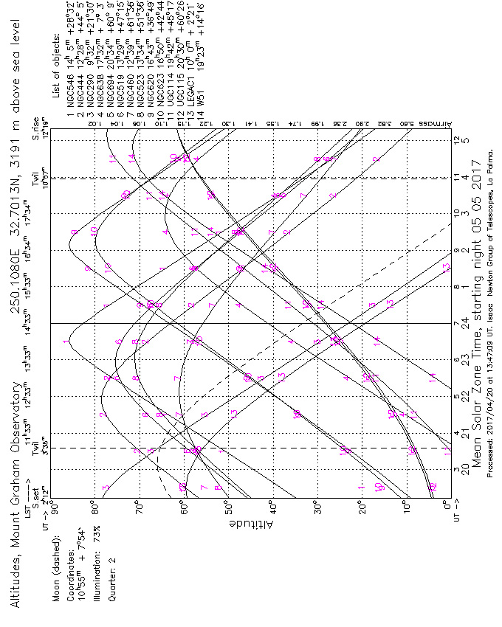

MPE

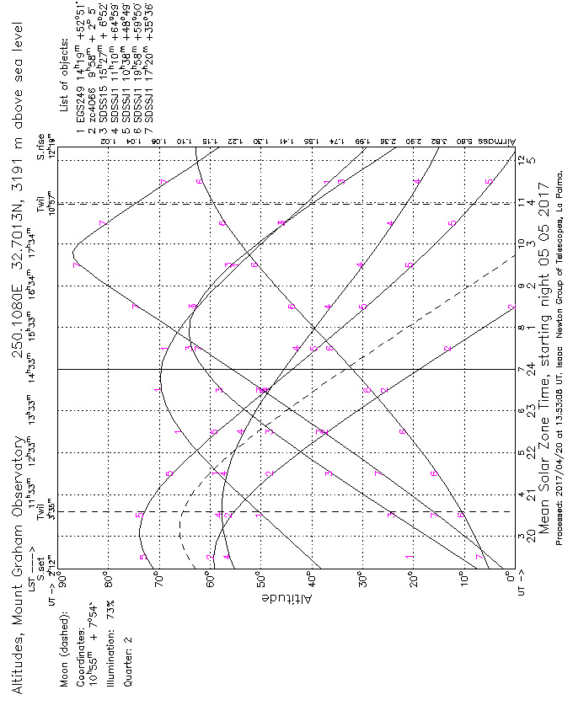

UA

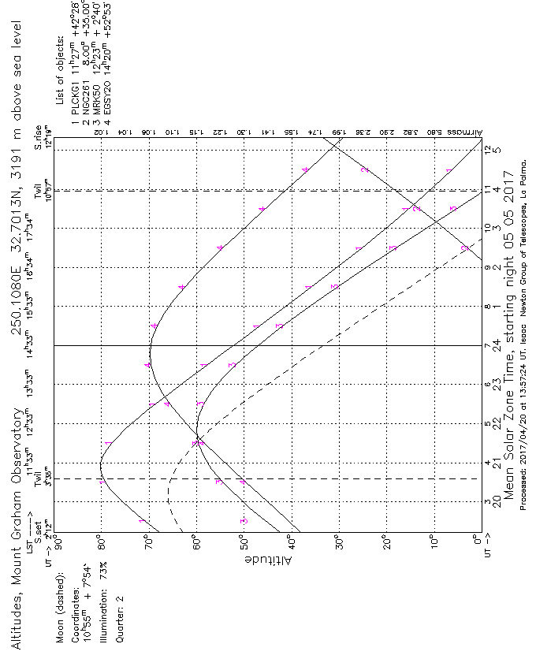

Virginia

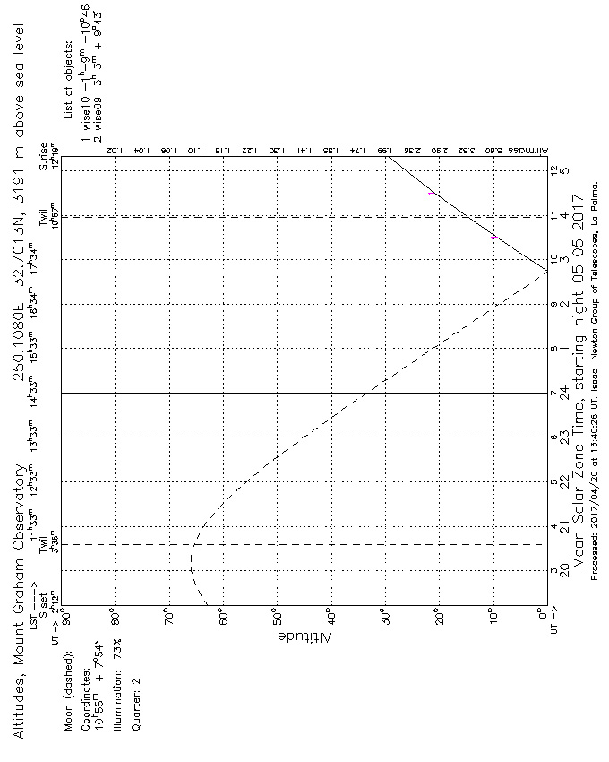

Photo standards

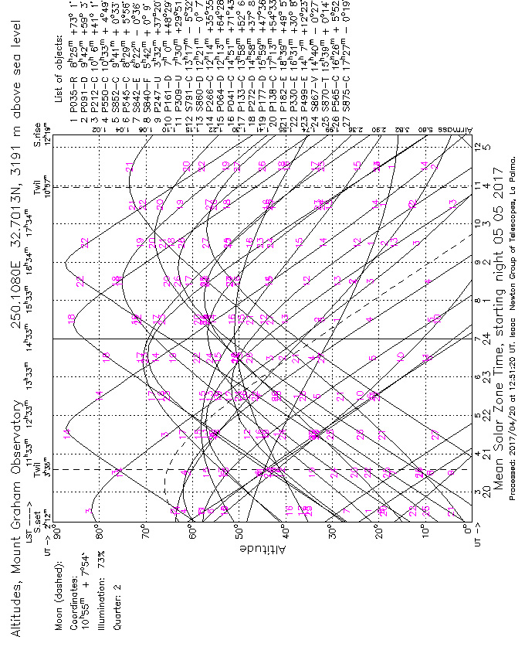

Southern stars

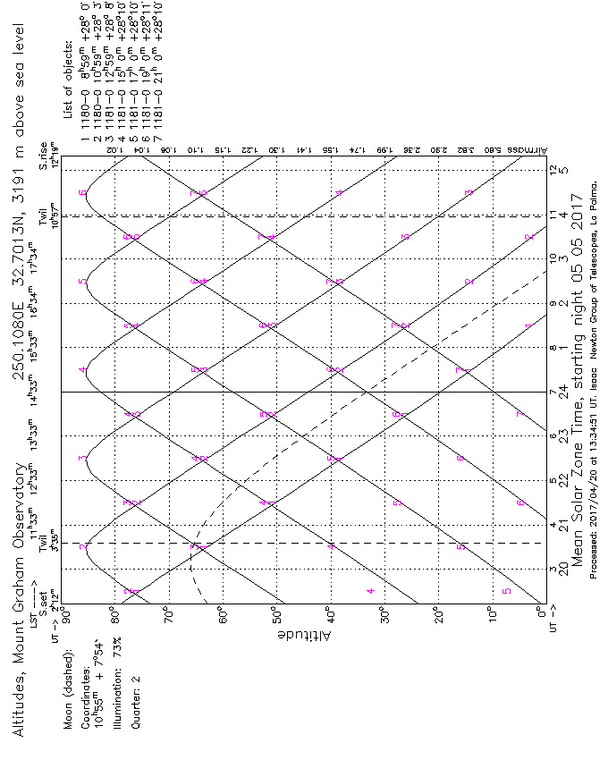

Northern stars

