September 2014 DX CalUnit measurements

# Setup procedure

The requirements for this procedures are:

* DX dichroic unit must be installed on telescope
* LEDs module must be reinstalled on the C-ring supply rack and the fibers to the CalUnit must be set in place

## How to deploy ARGOS CalUnit

### **Cal unit deployment procedure**

- Enable telescope Stow Pins

- Put telescope on HBS

- Laptop and climbing tools are stored on 3L, on ARGOS shelves

- Attach laptop to power cord and gray ethernet cable

- Laptop login: argos, pwd: argos2009

- Climb and remove optics cap

- On laptop click first "set default parameters", then "reset", then "move to working position"

- Switch off high floods lights (1st and 2nd botton on "lighting" tab on telescope control gui)

- Deploy dichroic

### **Switching on light**

- login into LALAS: IP 192.168.26.149, pwd: argos123

- ON-AXIS SOURCE REFLECTION: argos_dx_cal_white_light_source_gui

- ON-AXIS SOURCE TRANSMISSION THROUGH HOLOGRAM: argos_sx_cal_white_light_source_gui

- OFF-AXIS SOURCES: argos_dx_las_or_lgsw_swing_arm_diode_source_gui

## How to setup ASM

Instructions on how to setup M2 and M3 on the positions used in May 2014 daytime and nighttime activity are contained in the file: [Instructions_to_replicate_the_Hexapod_position.docx](http://aowiki.arcetri.astro.it/pub/ARGOSPublic/DiaryTechRun0/Instructions_to_replicate_the_Hexapod_position.docx)

Since both M2 and M3 have been reinstalled after the summer shutdown we think the starting point is to apply the new “default” positions when the LUCI@ARGOS focal station is authorized for on-sky operations. Then a differential offset with respect to the default position can be applied to reproduce the position we used in May for LGSW calibrations:

|  |  |  |  |
| --- | --- | --- | --- |
| X offset | -1.784 mm | RX offset | +175 arcsec |
| Y offset | -2.150 mm | RY offset | +70 arcsec |

The procedure to apply offset to the hexapod DoF is detailed in the document: instruction how to replicate Hexapod positions.doc

The Z offset is strongly dependent on the dome temperature and so it will be better to adjust it at need. As reference the absolute position used on May was +4.500 mm.

## Hot to deploy ARGOS dichroic

The complete procedure about how to install/remove the full dichroic mount from telescope is detailed in document ARGOS_dichroic_installation.pdf

The manual procedure to deploy the optics is the following:

1. Remove the fabric and metal covers on both optics.
2. Open the LGSW rack door on the LUCI platform and find the dichroic controller module:

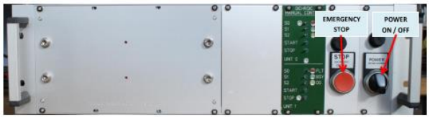

1. In the dichroic controller panel move lever S0 unit 0 to left (this selects the deployment program for the dichroic)

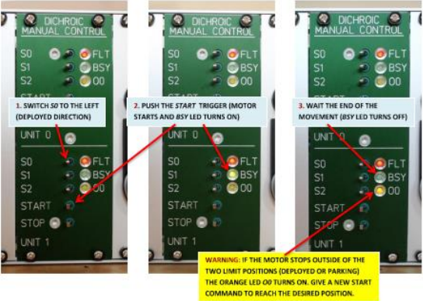

1. Push start trigger on unit 0, BSY LED turns on
2. Wait that dichroic cart reaches working position and BSY LED turns off on the panel
3. Move lever S0 unit 1 to left (this selects the deployment program for the fold mirror)
4. Push start trigger on unit 1, BSY LED turns on
5. Wait that fold mirror arm reaches working position and BSY LED turns off on the panel

## How to identify LGSW axis on the table

The LGSW axis is coincident to the center of the 3 LGS asterism. The procedure we used to visualize this axis on the LGSW table is detailed in the document Alignment_report.pdf

The results of the LGSW alignment procedure are resumed here: 140211_report.pptx

The output of the alignment procedure was placing pins on the table where the LGSW board must be placed.

In the LGSW cabinet a metal rod and a flange are available to reproduce the LGSW axis once they are placed on the reference pins on the table:

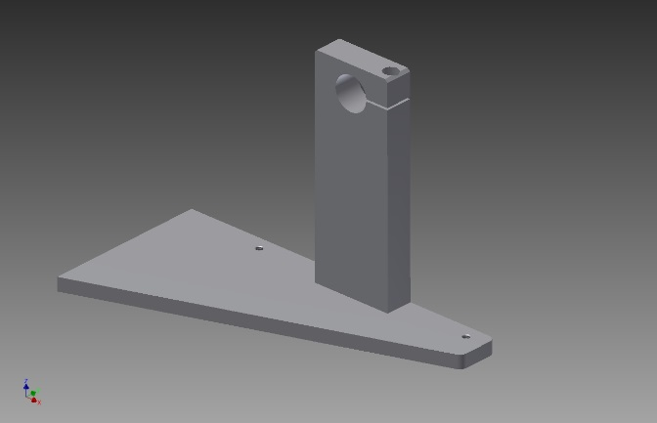 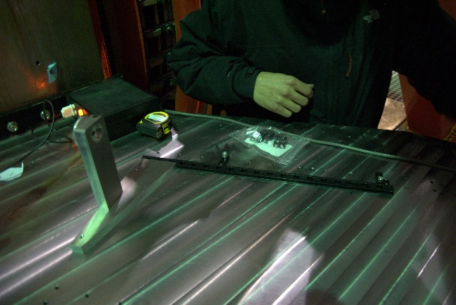

We suggest to place a metal sheet on the front part of the flange and stick to it a graph paper sheet. On the paper it is necessary to mark the position of the LGSW axis so it will be possible to measure the distance of the LGS spots from the mark.

# Measurement procedure

Here we suppose the measurement tool will be the flange used for the LGSW alignment, sliding along its metal rod fixed to the pins. On the flange we put a graph paper sheet and we marked the position of the LGSW axis.

## LGS interdistances

1. We place the flange in correspondence of the marker sign indicating the Z position of the front of the LGSW board. Here we mark the point at 150mm distance from the pins (correspondent to the LGSW axis).
2. We slide the flange until the 3 LGS are in focus. We measure the distance between the mark of point 1 and the actual position.
3. We mark the position of the 3 LGS on the graph paper. We take pictures and we measure the interdistances between the marks
4. We slide the flange in Z until the spots become ~10mm diameter (~166mm from point 2). We measure the Z distance from point 2.
5. We mark the envelope of the 3 LGS and we take pictures.
6. We slide the flange until the spots are 20mm. We measure the Z distance from point 2,
7. We mark the envelope of the 3 LGS and we take pictures.
8. At this point we can remove the graph paper, determine the center of the envelopes, measure the interdistances of the LGS at the different Z positions.

## LGS axis direction wrt LGS axis

Having marked the positions along Z of the 3 LGS we can determine for each Z the center of the 3. The interdistances between the centers will give the measure of the angle between the LGS and LGSW axes.

## Position of the hologram orders

1. We slide the flange along the rod until the other hologram orders come into focus.
2. We measure the distance between the LGSW board front mark and the positions of the flange.