# Instructions to replicate the Hexapod position

Instructions extracted from Alfio email of 16/09/2014

1) Check that hexapod is homed:  
  
   1a) open the OSS GUI (if it is not yet available anywhere, type "OSSGUI" at a terminal on an obs workstation)

   1b) click on the hexapod symbol on the right side

   1c) the hexapod OSS GUI opens (see Figure 1). Check that the "Mirror Homed" indicator is green. If it is yellow, you need to click on "Home" and wait a couple of minutes until it turns green

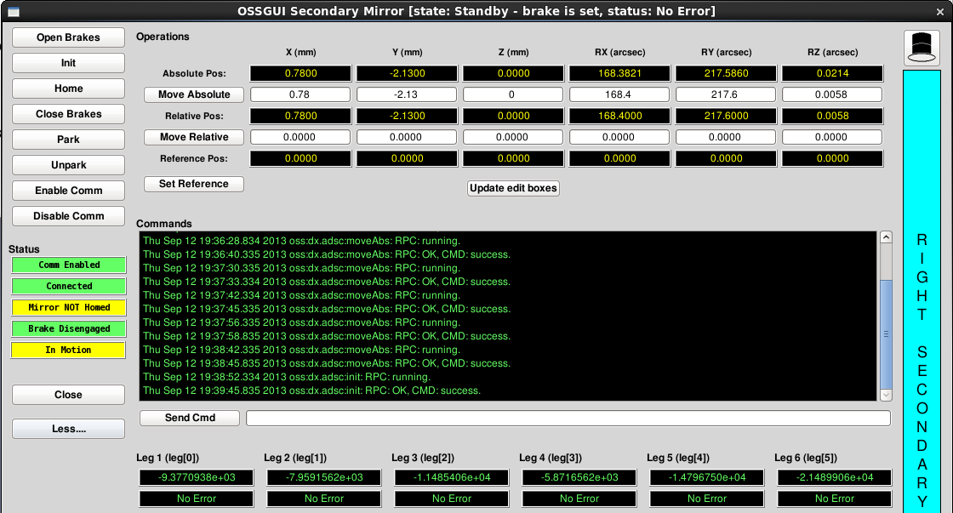

Figure 1. Hexapod OSS GUI.

2) Apply the desired position:

   2a) open the PSF right GUI (type "PSFGUI right" at a terminal on an obs workstation).

   2b) the main PSF gui opens (see Figure 2). Click on the "Secondary" button

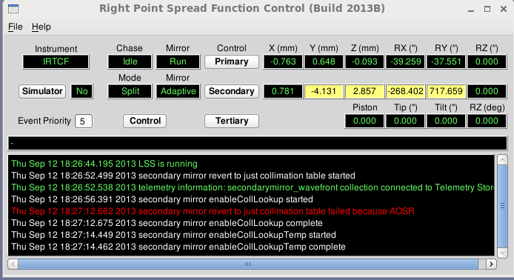

Figure 2. PSF main GUI.

   2c) the PSF Secondary GUI opens (see Figure 3). The "hexapod" numbers at top-left are the realtime hexapod position. The "Total Collimation" value at top-right is where the hexapod will move at the next update. We want the "Total collimation" value to be the same as our position.

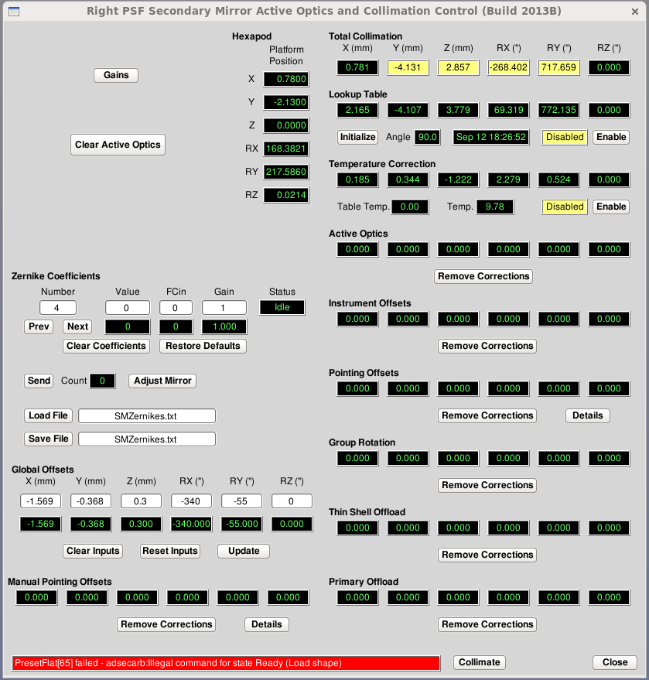

Figure 3. PSF secondary GUI.

In order to to this:

   2d): remove all corrections in the right column. Disable the two lookup tables. Enter our position in the global offsets at bottom left. Click on "update". The desired positions should be readable on the Hexapod Platform Position column.

# Positions recorded on ARGOS commissioning run of May 2014

## Daytime activity with ARGOS calibration unit

These positions refer to the calibration activity performed on 11th May 2014 when the AO loop was closed on FLAO using the on-axis source and at the same time the off-axis Yellow source was imaged on the ARGOS Patrol camera.

Table 1. Daytime positions from 20140511.

|  |  |  |
| --- | --- | --- |
| HEXAPOD | X | -4.14 |
| Y | -7.21 |
| Z | 4.23 |
| RX | 0.91 |
| RY | -148 |
| RZ | 0.02 |
| M3 | POS0 | -558.09 |
|  | POS1 | 329.961 |
|  | POS2 | 0.0 |
|  | POS3 | -25.9 |
| W board stages | X ABS | -74.13 |
|  | Y ABS | -57.31 |
|  | Z ABS | 28.99 |

## On-sky positions

These positions have been recorded when the AO loop was closed on sky with the FLAO on the 16th of May 2014 imaging M83 on LUCI2.

Table 2. Nighttime positions from 20140516.

|  |  |  |
| --- | --- | --- |
| HEXAPOD | X | -5.24 |
| Y | -4.69 |
| Z | 2.18 |
| RX | 32.11 |
| RY | -360.84 |
| RZ | -0.02 |
| M3 | POS0 | -757.88 |
|  | POS1 | 580.02 |
|  | POS2 | 0.0 |
|  | POS3 | -25.83 |
| W board stages |  |  |
|  |  |  |