










Procedure for installing and removing ARGOS dichroic mount on the telescope

Doc. No. ARGOS Technical Note 119
Issue 1.0
Date 13/01/2014

Prepared M. Bonaglia 2014/01/13
Name Date

TABLE OF CONTENTS

1 Scope 2
2 Applicable documents 2
3 Notes 3
4 Authorized personnel 3
5 Required material 3
6 Equipment description 4
7 Removal of the ARGOS dichroic mount unit □ DX □ SX 10

Change Record

Issue | Date | Section/ Paragraph Affected | Reasons / Remarks | Name
1.0 | 13.01.2014 | all | created | M. Bonaglia

Scope

This document describes the procedure for removing the ARGOS dichroic mount from the storage stand, transporting to the telescope, and mounting on the bent Gregorian focal station of LUCI. The opposite procedure is also detailed.

Applicable documents

No. | Title | Number & Issue
AD 1 | ARGOS DICHROIC MOUNT HANDLING INSTRUCTIONS | M13.11.12
AD 2

Notes

This document describes the different procedures needed to handle, install and remove the dichroic mount at the telescope. Two long term configurations are foreseen for the dichroic mount:
- When operational the mount is installed on front of the LUCI rotator in the rotator gallery.
- When stored the mount is installed on the static stand, sealed by a dust cover and stored in the clean room
The installation procedure, detailed in section 7, starts in condition B and ends with dichroic mount in condition A. The removal procedure, detailed in section 8, has opposite conditions.

Required personnel

- Procedure Supervisor
- Telescope operator.
- Crane operator.
- Two persons to perform the procedure.

Required material

- 4x M14 (length?) screws (to attach the Dichroic Mount unit to the Handling Device)
- 3mm (M4) Allen wrench
- 12mm (M14) Allen wrench
- 14mm (M18) Allen wrench
- 110V power cord
- 1 set of spare Dichroic Mount cables
- Dichroic Mount Handling Device with chains and ring
- Dichroic and Fold Mirror covers
- Dichroic Mount storage stand
- Telescope Crane
- Crane scale

Equipment description

- Dichroic Mount Unit: depicted in Figure 1 it is composed oy a common support structure for both the dichroic and fold mirror sliding mounts and the 2 optic cells.
It interfaces with the Handling Device through 4x M14 holes and with the Rotator gallery pads with 4x M18 captive screws.

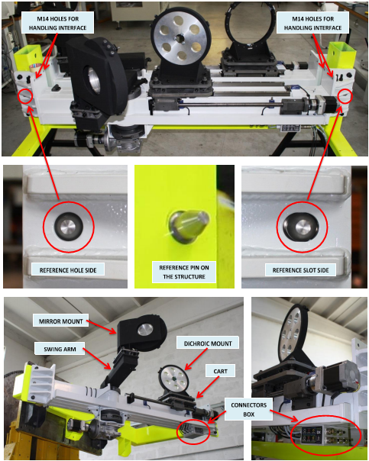
Figure 1. Image of the ARGOS dichroic mount unit and its interfaces to the Handling device and the Rotator gallery pads.
- The Handling Device: a custom made tool necessary to lift the Dichroic mount unit (see Figure 2). Its interface with the dichroic mount are 4x M14 pass-through holes, it must be hanged to the crane using the red ring at the end of the 2schains. The 2 chains are already been calibrated on the dichroic mount weight distribution.

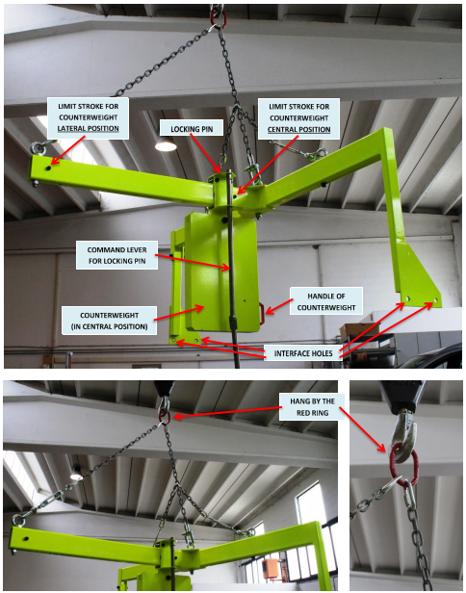
Figure 2. Image of the Handling device, its interface with the dichroic mount and crane.
- Storage stand: it is a carriage designed to hold the 2 dichroic mounts in the storage facility. A plastic cover is provided to keep dust off the units.
Interfaces with the 2 Dichroic Mount units are 4 pads identical to the ones installed on the telescope gallery.

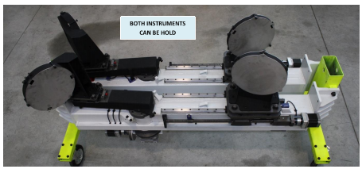
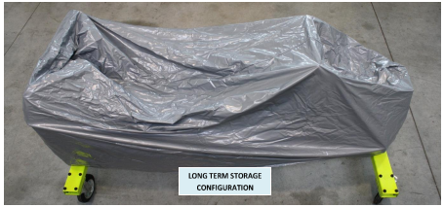
Figure 3. Image of the storage stand with the 2 dichroic mounts mounted on it and the dust cover.
- Optic covers: there are 2x stainless steel covers for the Dichroic and 2x for the Fold Mirror. They must be mounted on the optics before handling the mount itself. Figure 4 shows how to install the covers on thedichroic cell. The fastening screws are captive and can be tightened with a 3mmaAllen wrench. Fold mirror is treated accordingly.

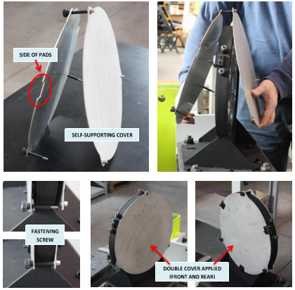
Figure 4. Installation of the dichroic cover.
- Rotator gallery interface pads: each side of the telescope is provided with 2x black pads, highlighted in Figure 5 where the dichroic mount is bolted to. The interface with the dichroic mount are 4x M18 captive screws fixed to the mount itself. 2x pins allow a precise placement of the mount when removed and reinstalled.

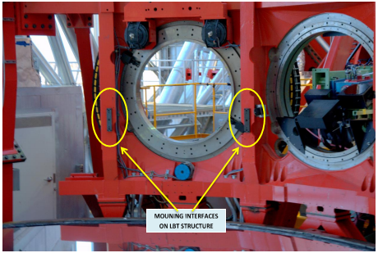
Figure 5. Picture of the rotator gallery pads installed on the SX side.
- Dichroic controller: this is a standard rack unit hosting 2 X-mind RTA controllers to displace the dichroic and fold mirror mounts between their operational and parked positions, defined by hard end stops and provided with limit switches.
During installation and removal procedures the dichroic controller is operated in manual control acting on the levers on its front panel. LEDs give feedback of the mounts deployment status.
The controller input is a 110V power line, the output are the set of dichroic cables that must be connected to the connectors box below the dichroic mount.

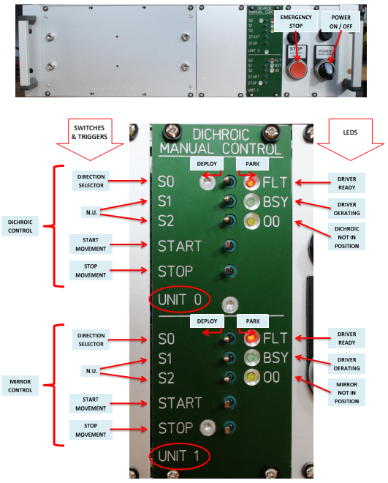
Figure 6. Image of the dichroic controller rack unit and detail of the manual control panel. Different levers and LEDs functionalities are highlighted.

Installation of the ARGOS Dichroic Mount □ DX □ SX

# | Procedure | By | Time
PREPARATION
 | 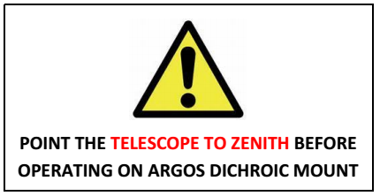
 | Install platform above M1 (or alternatively, have a person properly secured in position in the working area, in front of the corresponding LUCI port). TBD
 | Verify that the LUCI Cal Unit is in parked position
 | Rotate the building to 120° and open the hatch for access from the Telescope Chamber to the High Bay
 | Bring the Dichroic Mount unit on its storage stand into the High Bay area and brake the wheels. Verify that the Dichroic and Fold Mirror covers are in place.
SETUP OF THE UNIT PRIOR TO INSTALLATION
Bring the following items to the High Bay, close to the storage stand:
- Spare set of dichroic mount cables from the ARGOS spare cabinet
- Dichroic Controller
- 110V power cord.
Connect all the 7 cables of the spare set to the dichroic mount connector box
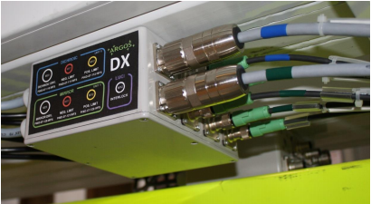
 | Connect the 7 cables to the dichroic controller back panel
 | Connect the 110V power cord to the dichroic controller
 | Turn on the dichroic controller
 | If dichroic is already in the Parking position, skip to step 15 (deployment of the mirror arm).
In the dichroic controller manual control panel move lever S0 unit 0 to right (to park the dichroic).
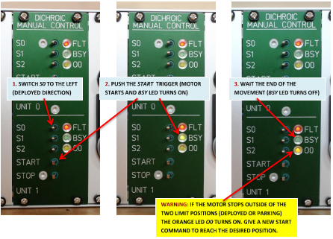
 | Push start trigger on unit 0, BSY LED turns on
 | Wait until dichroic cart reaches parked position and BSY LED turns off on the panel
 | Move lever S0 unit 1 to left (to deploy the mirror arm).
 | Push start trigger on unit 1, BSY LED turns on
 | Wait until fold mirror arm reaches work position and BSY LED turns off on the panel
 | Turn off dichroic controller power
 | Disconnect all 7 cables from the dichroic mount connector box.
ATTACHING THE UNIT TO THE HANDLING DEVICE
Bring the Handling Device into the High Bay area from its storage location (TBD). Verify that its counterweight is in the “Central” position (for use without the Dichroic Mount unit).
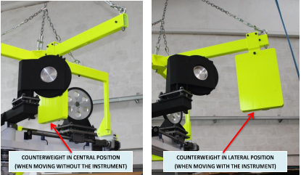
Check that locking pin is inside the hole
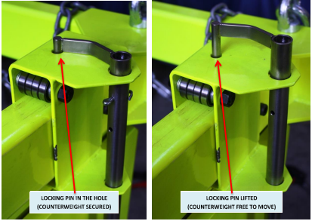
 | Hook up the crane scale to the crane, and lower it into the High Bay. Then hook up the chains of the Handling Device to pick it up (using the provided red ring holding the chains together).
Lift the Handling Device, position it next to the Dichroic Mount unit and move it slowly towards the unit.
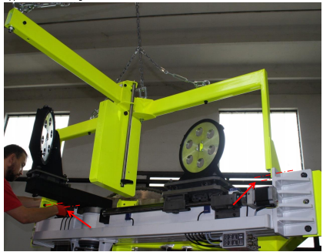
 | Match the 4x M14 holes in the Handling Device with the Dichroic Mount unit pass-through holes.
 | Secure the Dichroic Mount unit to the Handling Device with 4x M14 screws.
 | Tighten the 4x M14 screws with a 12mm Allen wrench
 | Move the counterweight of the handling device to the “Lateral” position (for use with the Dichroic Mount unit): lift the locking pin and gently push the counterweight using the orange handle.
 | Check that the locking pin to falls in his hole securing the counterweight position.
MOUNTING THE UNIT
 | Fly the unit to the telescope and bring it to the mounting location. Total weight is TBD.
 | Position the Dichroic Mount unit using the reference pins on the mounting interfaces attached to the gallery beams. Keep checking the weight on the crane scale.
 | Fasten the 4x M18 screws with a 14mm Allen wrench.
 | Move the counterweight of the handling device to the “Central” position (for use without the Dichroic Mount unit): lift the locking pin and gently pull the counterweight using the orange handle.
 | Check that the locking pin to falls in his hole securing the counterweight position.
 | Gently remove the 4x M14 allen screws to free the Handling Device from the unit.
 | Using the crane, slowly move the Handling Device away from the unit. Weight is TBD.
 | Fly Handling Device to storage location (TBD).
RECONNECTIONG CABLES
 | Connect all 7 cables on the Dichroic Mount connector box.
REMOVING THE COVERS
Remove the Dichroic covers:
Loosen the 3 captive screws of the Dichroic covers with a 3mm Allen wrench
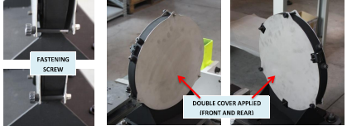
IMPORTANT: Extreme care must be taken if the covers are being handled above the primary mirror. Tethering?
Remove the Fold Mirror covers:
Loosen the 3 captive screws of the Fold Mirror covers with a 3mm Allen wrench
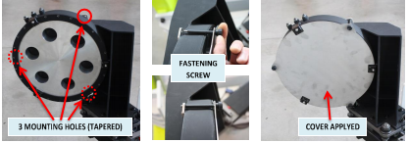
IMPORTANT: Extreme care must be taken if the covers are being handled above the primary mirror. Tethering?
 | Store the covers with the Storage cart (location TBD)
FINAL
 | Remove platform from M1 (if platform was used) TBD
 | Store Handling Device and Storage Stand in TBD.

Removal of the ARGOS dichroic mount unit □ DX □ SX

# | Procedure | By | Time
PREPARATION
 | Install platform above M1 (or alternatively, have a person properly secured in position in the working area, in front of the corresponding LUCI port).
 | Verify that the LUCI Cal Unit is in parked position
 | Rotate the building to 120° and open the hatch for access from the chamber to the High Bay
Bring the following items to the High Bay, close to the storage stand:
- Spare set of dichroic mount cables from the ARGOS spare cabinet
- Dichroic Controller
- 110V power cord.
INSTALLATION OF THE COVERS
Install the Dichroic covers:
Tighten the 3 captive screws of the Dichroic covers with a 3mm Allen wrench
Install the Fold Mirror covers:
Tighten the 3 captive screws of the Fold Mirror covers with a 3mm Allen wrench
SETUP OF THE UNIT PRIOR TO REMOVAL
 | In the Dichroic Controller manual control panel move switch S0 on unit 0 (Dichroic) to the right
 | Push start trigger on unit 0. BSY LED turns on
 | Wait until the Dichroic cart reaches the parked position and BSY LED turns off on the panel
 | Move switchS0 on unit 1 (Fold Mirror) to the left
 | Push start trigger on unit 1. BSY LED turns on
 | Wait until the Fold Mirror arm reaches work position and BSY LED turns off on the panel
Turn off dichroic controller power
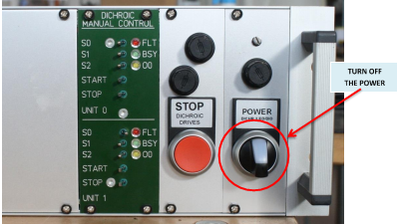
 | Remove the dichroic controller unit from the rack
 | Unplug all the cables and optical fibers from the controller back panel
 | Bring the controller unit down to the High Bay and leave it next to the storage stand
 | Disconnect all 7 cables from the dichroic mount connector box(located below the dichroic mount).
SETUP OF THE HANDLING DEVICE
 | Hook up the Handling Device to the crane scale using the provided red ring holding the chains together.
 | Put the counterweight of the handling device in the “Central” position
 | Check that the locking pin is inside the hole
REMOVAL OF THE UNIT
 | Fly the Handling Device to the telescope and bring it to the mounting location. Device weight is TBD.
 | Move the Handling Device slowly towards the Dichroic mount
 | Match the 4x M14 holes in the handling tools with the dichroic mount pass-through holes
 | Secure the dichroic mount to the handling device with 4x M14 screws
 | Tighten the 4x M14 screws with a 12mm allen wrench
 | Move the counterweight of the handling device to the “Lateral” position (for use with the Dichroic Mount unit): lift the locking pin and gently push the counterweight using the orange handle.
 | Check that the locking pin falls in its hole securing the counterweigth position
 | Slowly release the 4x M18 allen screws with a 14mm allen wrench
 | Check that the M18 screws remain joined to the dichroic mount
 | Slowly move the Handling Device + Dichroic Mount away from the telescope pads. Total weight is TBD.
 | Fly the unit to the storage stand in the High Bay.
STORAGE OF THE UNIT AND FINAL STEPS
 | Remove the plastic dust cover from the storage stand
 | Match the dichroic mount in the reference pins on the storage stand
 | Fasten the 4x M18 screws with a 14mm allen wrench
 | Move the counterweight of the handling device to the “Central” position (for use without the Dichroic Mount unit): lift the locking pin and gently pull the counterweight using the orange handle.
 | Check that the locking pin falls in its hole securing the counterweigth position
 | Gently remove the 4x M14 allen screws to free the Handling Device
 | Slowly remove the Handling Device from the Dichroic Mount on the storage stand
 | Connect all the 7 cables of the spare set to the Dichroic Mount connector box
 | Connect the 7 cables to the dichroic controller back panel
 | Connect the 110V power cord to the dichroic controller
 | Turn on the dichroic controller
 | Move switch S0 on unit 1 (Fold Mirror) to the right
 | Push start trigger on unit 1, BSY LED turns on
 | Wait until the Fold Mirror arm reaches its park position and BSY LED turns off on the panel
 | Turn off dichroic controller
 | Unplug all the cables from dichroic controller back panel
 | Unplug all the 7 cables from dichroic mount connector box
 | Install the plastic dust cover on the service stand
 | Reinstall the dichroic controller in the LGSW rack, connecting all the cables and optical fibers on the back panel
 | Turn on the dichroic controller
 | Release thebrakes of the storage stand wheels
 | Pull service stand on the elevator
 | Bring the set of spare cables, the 110V power cord and storage stand to their storage location (TBD)
 | Take the Handling Device to its storage location (TBD)
 | Park the storage stand somewhere in the Clean Room (TBD) and apply the wheel brakes
 | Store the set of spare cables in the ARGOS spare cabinet
 | Remove platform from M1 (if platform was used) TBD

End of document

