










Test of Lenslet array mount stability

Doc. No. ARGOS Technical Note 108
Issue 1.0
Date 29/03/2011

Prepared L. Busoni, M. Bonaglia 2011/03/29
Name Date

TABLE OF CONTENTS

1 Scope 2
2 Applicable documents 2
3 Introduction 3
4 Measurement setup 3
5 Flexion of the LA mount 4
6 Conclusion 5

Change Record

Issue | Date | Section/ Paragraph Affected | Reasons / Remarks | Name
1.0 | 29.03.2011 | all | created | M. Bonaglia

Scope

This document analyzes the stability of the mechanical support structure for the wavefront sensor lenslet array. This analisys has been done measuring with on a CCD camera the position of a light spot generated through a laser beam and a set of pinholes.

Applicable documents

No. | Title | Number & Issue
AD 1
AD 2

Introduction

The lenslet array mount technical drawing is showed in Error: Reference source not found. In the final design of the wavefront sensor this mount carries the 24mm diameter lenslet array produced by SUSS. The mount allows the adjustment along the rail (Z or optical axis) for focusing and clock adjustment (± 10°) via the rod placed in the upper side of the mount. A lock is provided and a tension adjustment is offered by the threaded retaining ring.

Figure 1. Drawning of the lenslet array mount. The XY coordinate system is showed.
X
Y

To test the stability of the lenslet array mount it has been necessary to thread the hole facing to the incoming beam (part numbered as 2 and 4 in Error: Reference source not found). On this thread we mounted a commercial Thorlabs tube of 1” diameter and 75mm length. The tube holded two pinholes of 100 and 50µm diameter in sequence.

Measurement setup

The setup used to test the lenslet array mount flexions is showed in Figure 1. A laser source emitting a collimated beam of 2mm diameter is holded on the axis passing through the two pinholes. The pinholes are mounted inside a Thorlabs tube of 1” diameter and 75mm length. The effective distance between the 2 pinholes is D=70mm. This ensures an acceptance angle for the source of α = ± (d₁+d₂) / 2D = ±0.06deg, where d₁ and d₂ are the diameters of the pinholes (100 and 50µm respectively).

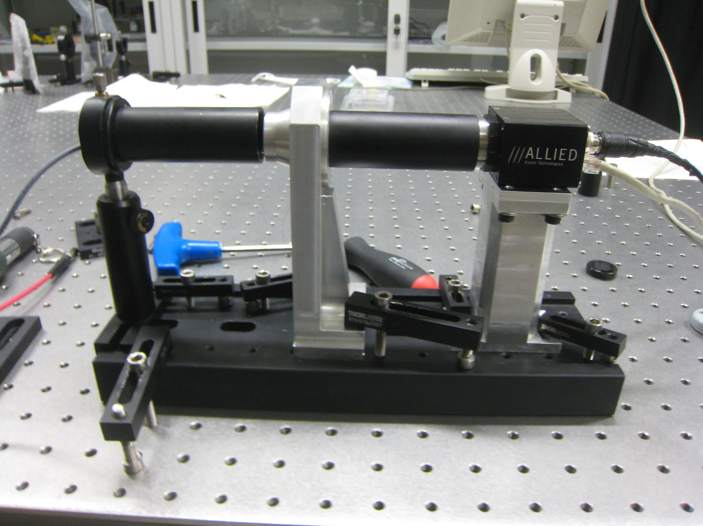
Figure 1. Optical setup used to evaluate the flexion of the LA mount. The laser source is contained in the first tube on the left. The 2 pinholes are mounted in the tube screwed on the LA mount.

The tube is screwed to the lenslet holder in such a way that the 50µm pinhole is positioned at a distance of f=15mm from a CCD camera (Prosilica GC1350, pixel size = 4.65µm, 1360x1024px full frame). The expected FWHM of the spot is: l = (λ/d₂) /1.22 * f = 130µm, that means ~28pixels.

Flexion of the LA mount

We first acquired the spot position with the system in “rest” position. To do this we acquired 10 frames with the camera and we evaluated the centroid on a subframe of 200x200px of the averaged image. Figure 2 shows the averaged image and the cut through the peak. The evaluated FWHM is 23px ~ 107µm.
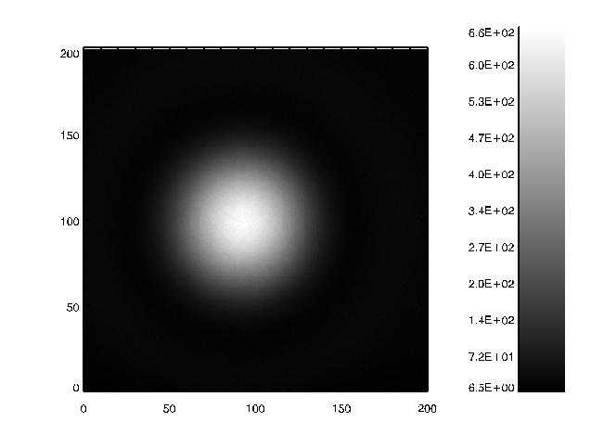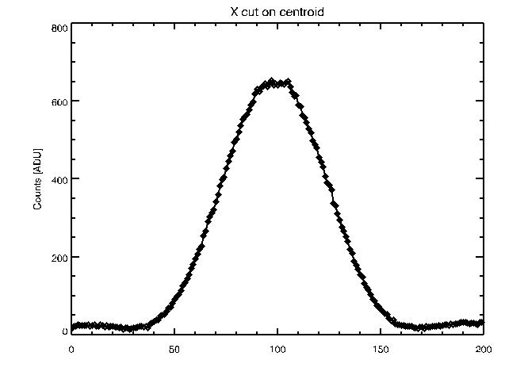
Figure 2. Left: image of the spot when the system is in the "rest" position. Right: row cut of the centroid.

To evaluate the flexion of the LA mount we pulled strongly the mount by hand and we measured again the spot position. This solution has been preferred to tilting the entire system because it avoids displacements of the light source.
Then we acquired a new “rest” position and afterward we pulled the mount. Results of the measures are resumed in graph below:

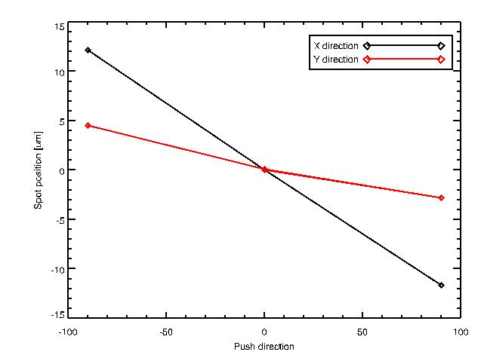
Figure 3. Results of the stability test. The spot position measured on the camera has been plotted in function of the push direction.

Conclusion

We evaluated the flexion of the lenslet array mount when a strong weight is applied in the X direction. The measured flexion of the mount is ±12µm for an average weight of 30kg. Once the weight is removed the system returns in the “rest” postion within less than 0.05µm. On these results we expect no significant flexion of the mount when it holds only the lenslet array (~0.2kg total weight).

End of document

