FLAO State Machine 2.0

Document ID: XXXXXXXX-XXX

A. Puglisi
L. Fini
J.C. Guerra
E. Pinna
……
…...
……
Prepared by
Name Date

Reviewed ………..
Name Date

Change Record
Issue | Date | Modification Author(s) | Section/Paragraph  affected | Reason/Remarks
Draft | XXX | all | all | First Draft of the document

Table of Contents
1 Scope 3
2 Introduction 3
3 General strategy 3
3.1 User control over the close-loop sequence 4
3.2 Recovering after loop open 4
3.3 Asynchronous stop 4
3.4 Telescope status of previous steps 5
3.5 GUI mock-up 5
4 New closed-loop sequence 6
4.1 General description 6
4.2 Re-closing the loop after a sudden stop 6
4.2.1 Environmental information gathering 6
4.2.2 Preset 6
4.2.3 Star centering 6
4.2.4 Pupil centering 7
4.2.5 Flux estimation 7
4.2.6 Preliminary loop closing 7
4.2.7 Gain optimization 7
4.2.8 Loop stop 7
5 Abbreviations, acronyms and symbols 8
References 8

Scope
…………….

Introduction

….. Description of the current state of the SM, the main issues and the goals of the new SM….

General strategy
The closed-loop sequence (from preset to closed AO loop) will be split into a greater number of steps than now (from 3 steps to 7-8), to allow finer control over the process. The new steps are described in detail in section 5. This modification will be implemented at the AO arbitrator level, keeping the interface towards the TCS identical to the existing one.

The AO system will save a complete configuration snapshot at the end of each step, including all movement positions, AdSec configuration (gains, reconstructor, etc.) and open/closed loop status. This will allow the system to roll back to any of the saved snapshots, as described in more detail below.

A new engineering GUI will be developed, which will allow an advanced user to interact with the new sequence (a mockup of this GUI is provided in sect. 4). Part of this functionality will also be implemented in the AOS GUI, possibly once experience has shown which are the most common occurrences.

It should be remembered that the AO system is setup by the telescope IIF using two commands: PresetAO (which blindly presets the system, without looking at the sky) and AcquireRef/RunAO (which starts the star acquisition and loop closing procedures). The AO system will execute these commands using two different modalities (chosen with a switch on the AOS GUI):

- AUTO: this mode will work pretty much like today, where the system tries to close the AO loop without user intervention. In case of failures for any reason, the preset will be canceled and a new one will need to be reissued. Optionally, the system can ask to the user whether to cancel the preset or switch to manual mode.
- MANUAL: this mode requires the user to manually step the system up to closed loop, as in the following scheme:
  - Preset telescope as usual. This will also preset the AO system
  - Issue RunAO from the IIF. Instead of proceeding automatically, the AO system will suspend execution waiting for operator commands from the new GUI. The new GUI will show the current status of the sequence, and user will choose between several actions (parameter change, retry, rollback, skip, etc.) described in detail in sect. 3.1. Also, the new GUI will allow the user to change the sequence, for example skipping a step that is known to be not necessary in the particular conditions;
  - When the sequence has been completed, the TCS will be informed that the loop is closed and that observation can begin;
  - If the loop opens for any reason, the TCS is NOT informed immediately. Rather, the GUI will allow the operator to re-close the loop as described in sect. 3.4 (changing some parameters, if required), or cancel the preset;

This document will focus almost exclusively on the MANUAL mode.

User control over the close-loop sequence
While in MANUAL mode, the system waits for the user to star the execution of each step (with the exception of the first Preset step, which is executed automatically when the telescope is preset). Each step may 1) complete successfully, 2) fail because of an error or 3) abort on user request. In all cases, the GUI will display the current status of the sequence together with the main system parameters and the possible actions that the operator can take to solve the error, if any. From any step of the closed loop sequence, and irrespectively of whether the current step succeeded or failed, it will be possible to:
- Continue with the next step of the sequence (modifying some parameter, if required)
- Roll back to start of the current step and try again (modifying some parameter, if required)
- Roll back to the start of a previous step and try again from there (modifying some parameter, if required)
- Skip to one of the next steps (modifying some parameter, if required)
- Cancel the preset and return control to the TCS
An error is returned to the TCS only in case the user selects option 5. Otherwise, the TCS will consider the command still in execution and will wait until it either succeeds or is aborted by the user.
An example of a possible error could be a failure of the “pupil centering” step (see sect. 5.3.4). If the system cannot complete the centering automatically, it will suspend the execution of the sequence asking the operation to take an action on the AOS GUI. The operator may decide that:
- the failure was due to a temporary problem (i.e. a cloud passing over the telescope) and retry the current step.
- the procedure should restart from a previous point (i.e. because the star is way fainter than expected)
- the pupils are already sufficiently centered, or they can be centered manually using a low-level interface. In this case, the operator will tell the system to skip to the next step
- or finally that the system cannot be recovered, and abort the sequence.
In case of options 1 and 2, the snapshot saved at the end of the previous command is applied, undoing any actions performed by the failed steps. The user will have the option of overriding some of the parameter, if desired. In case of option 3, the new step will be started with the current configuration. Again the user will have the option of manually overriding the value of any desired parameter.

Force parameter option
Before the execution of each step, the user can force one or more parameters overwriting the current values. This will replace the values found in the snapshot.

Snapshots
A snapshot is a text file containing the full configuration of the system (device positions, adsec configurations, loop parameters, etc..). A snapshot is created at any of the following occurrences:
- Completion of any step of the sequence
- Completion of any command received from the TCS (i.e. offset XY)
- Force parameters

Recovering after loop open
If the loop opens without a shell RIP and the system is in MANUAL mode, it is often possible to reclose the loop almost immediately, because the star is still centered on the pyramid and the pupils did not move. Because of this possibility, the opening of the loop does not cause the preset to be canceled. Instead, control is returned to the user, who may choose to reclose the loop selecting a rollback to the step of gain optimization, which contains a full snapshot of the closed loop, or a previous step if required. Otherwise pushing the “abort preset” the operator will tell the TCS to cancel the preset.
It must be noted that, since the TCS is not informed of the loop opening, guiding and active optics will not be started. Therefore, the star will start to drift slowly out of the pyramid field of view. If the user delays action by more than a few minutes, it is likely that a fast loop recovery is not possible.
The same strategy can be used to attempt a loop recovery after a shell RIP: the user can set the shell again, and try to apply a previous snapshot and re-close the loop. However, after a shell RIP there is a greater probability that the loop will not be able to resume.

Asynchronous stop
In addition to previous options, a “stop” button is always available to interrupt the execution of the sequence. Interruption may be slightly delayed from the button pressing (i.e. if the system is in the middle of a long command like reconfiguring a CCD), but will be anyway done as soon as possible. The system will assume that the current sequence step failed, and present the user with the same interface as above.

Telescope status of previous steps
When the system is rolled back to a previous step, all internal AO parameters (filter wheel positions, CCD parameters, etc) are re-applied. However, the telescope collimation is outside of the control of the AO system. If it changed for any reason (i.e. a large tilt was offloaded to the hexapod, causing it to tilt significantly), it might happen that the rollback brings the system to an unworkable position. The AO system can monitor some of these conditions (namely, hexapod and tertiary mirror positions) and warn the user if differences are found.

Misc features
LBTI can benefit from multiple hotspots when performing step #3 (Star centering). This feature can be implemented making the hotspot an item in the snapshot, and making it configurable in the GUI: a widget can allow to choose between pre-configured hotspots, or to enter a new one, before starting the star centering step.

GUI mock-up

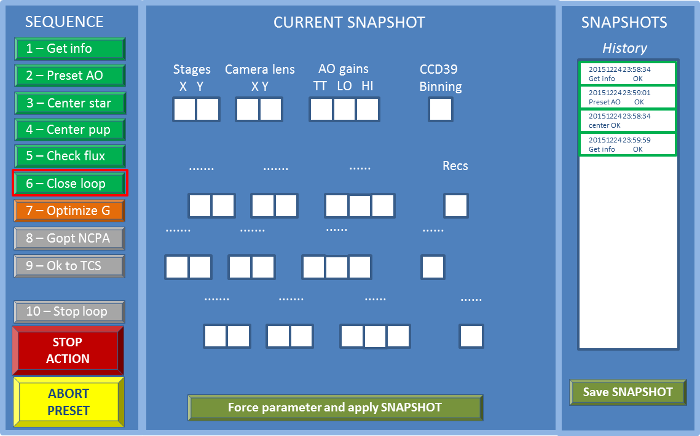

User GUI interaction
In AUTO mode, the above GUI is read-only and just provides status information. All steps are automatically executed until the full preset has succeeded, or an error has occurred.
In MANUAL mode, the user is expected to drive the system as follows: when the instrument sends a telescope Preset command in AO mode, the first two steps of the sequence are executed and their respective buttons turn green to indicate that the steps have completed successfully. After that, the instrument sends a RunAO command, and the GUI now waits for user input.
As a baseline operation, the user will then click on the sequence buttons in order, each button triggering a discrete step of the AO sequence, until the “Send OK to TCS” step has completed successfully.
After each step has completed successfully, a snapshot is saved on disk and appears in the list on the right. The last snapshot’s details are shown in the central part (only a subset of the snapshot is shown: the exact list is still TBD, and the idea is to have available all the parameters that the user might want to override with respect to the automatic configuration, i.e. the stage positions, AO loop gains, etc.)
At each step, the user can assess the situation (using CCD and/or instrument displays) and has the option to override the choices made by the automatic routines. This is done by manually modifying the parameter values, and clicking on the “Force parameters” button at the GUI bottom. This will create another snapshot with the user-entered values, that will be saved and immediately applied to the system.
The user can also choose to load a previous snapshot: double-clicking on the chosen snapshot on the list will load its details in the central part, and the snapshot can be applied using the “Force parameters” button at the bottom. As before, any parameter can be changed before applying the snapshot.
If a step fails, or is interrupted using the “Stop action” button, the same logic applies: a snapshot with the current system state is saved, and the user can override any parameter using the “Force parameters” button. The failed or interrupted step can then be repeated, or skipped altogether.
The sequence buttons can also be clicked out of order: for example, a step can be repeated if it failed, or a step can be skipped altogether if it is expected to fail because of known issues. The user can also choose to backtrack the sequence to a previous step, simply clicking the corresponding sequence button. In all these cases, it is the user responsibility to make sure that the system is in the correct state to execute the chosen button. For example, if the “Optimize gain” button is skipped, the correct AO gains have to be entered in the GUI and applied before going on with the sequence.

New closed-loop sequence

General description
The new AO loop sequence is the following:
- Gathering of environmental information
- Preset AO system
- Center reference star
- Center pupil and offload of aberrations
- Check flux and eventual reconfiguration
- Close loop
- Optimize gain
- Setup optical gain and apply NCPA (if any)
- Send OK to TCS
- Stop the loop (MANUAL mode only)

Steps 1-2 correspond to the old PresetAO command. Steps 3-5 correspond to the old AcquireRef command. Steps 6-9 correspond to the old StartAO command.
The closed-loop sequence is considered complete at the end of step 8. Depending on user requirements, steps 7 or 8 maybe skipped. However, no automatic reply is sent to the TCS, in order to allow the user to judge the loop quality and possibly adjust something (such as the AO loop gain) before sending a reply to the TCS. The reason is that, in most observing scripts, a reply to the TCS will give back control to the instrument software, that will probably start integrating or take some other actions that require a good AO loop quality. Making the reply to TCS an explicit step makes it possible to adjust something before the instrument starts to work.
Step #10 can be used to open the loop, without needing to restart all over from a preset. The user can instead choose any previous step to restart from.

Re-closing the loop after a sudden stop
The last step is also “executed” automatically when the loop opens because of a sudden problem (the so-called “skip-frame” condition or “shell RIP”). While in MANUAL mode, instead of re-executing the full sequence, the user can load a previous snapshot, eventually modify it and close again the loop clicking step 6 (in case of “shell RIP” the user will also need to set the shell manually).
If in AUTO mode, the open loop status will automatically imply the communication to the TCS and the cancellation of the preset. So that a sudden stop will imply to start all the operation from the IIF preset.

Steps descriptions
NOTE: The precise definition of each step is still TBD. The following is only a general description of each step.

Environmental information gathering
- DIMM value is read and stored

Preset
Very similar to the current preset:
- Filter wheels and CCDs are configured using lookup tables
- Backgrounds are taken on both ccd39 and ccd47
- XYZ stages are moved to the expected star position
- Pupil rotator and ADC tracking are started

Star centering
- One or more frames are averaged on the ccd47 and the star located
- XYZ stages are moved to center the star on the ccd47 hot-spot

Pupil centering
- AdSec is configured for centering loop
- All offloads are enabled
- Loop is closed and camera lens tracking is enabled
- Wait until camera lens is centered
- Loop is opened.

Flux estimation
- Flux on the ccd39 is measured
- System is reconfigured (frequency, binning, etc.) if the flux is different from the expected one
- If binning has changed, the previous step to center the camera lens is repeated

Preliminary loop closing
- AdSec is configured for AO loop with low gain (0.1 on 10 modes)
- All offloads are enabled
- Loop is closed
- Wait until all offloads are under a threshold

Gain optimization
- Gain optimization routine is started

Loop stop
- Stop the slope flow to the ASM
- Set flat shape to ASM

Abbreviations, acronyms and symbols

Symbol | Description

References
- xxxxxxx

END OF DOCUMENT

