FLAO user procedures

|  |  |  |
| --- | --- | --- |
| Prepared by |  | Lorenzo Busoni, Alfio Puglisi, Juan Carlos Guerra, Enrico Pinna, Simone Esposito |
| Approved by |  |  |
| Released by |  |  |

ABSTRACT

This document describes a set of procedures to operate the FLAO system. It focuses on daytime operations to check the functionality of the system before on-sky operations or after engineering work on the telescope that could require a functionality test.

It is not meant to provide information about how to calibrate the system, nor to provide a low-level description of engineering tasks.

It is not needed during night-time; for the standard on-sky operation the AOS GUI should provide the Telescope Operator with all the needed functionality.

**Modification Record**

| **Version** | **Date** | **Author** | **Section/Paragraph affected** | **Reason/Remarks** |
| --- | --- | --- | --- | --- |
| A | 21 Jan 2013 | L. Busoni, A. Puglisi, JC Guerra, E. Pinna, S. Esposito | All | First release of the document |
| B | 22 Jan 2013 | As above | All | Fine-tuned and new section on performance and elablib |
| C | 28 Jan 2013 | As above | All | Added sections on fastlink check and readout noise measurement. Several other minor changes. |
| D | 27 Sep 2013 | As above | 5, 13, 14 | Added sections on night-time preparations, preset tables and Pisces tasks. |
| E | 20 Jan 2014 | A. Puglisi | 3.3 | Fastlink test updated |
| F | 24 Nov 2016 | A. Puglisi | 1,2,13 | Updated for UAO |

**Abbreviations, acronyms and symbols**

| **Symbol** | **Description** |
| --- | --- |
| LBT | Large Binocular Telescope |
| AdSec | Adaptive Secondary Mirror |
| FLAO | First Light Adaptive Optics system |
| IRTC | Infrared Test Camera |
| WFS | Wavefront Sensor |

**Contents**

1 General considerations 5

2 Start and check Software status 5

3 Start system and check hardware status 6

3.1 Power On and Set AdSec Mirror 6

3.2 Power On FLAO WFS 6

3.3 Test Fastlink connection 6

4 Check WFS functionality 8

5 Prepare WFS for night-time operation 9

6 Operate the AO system in closed-loop in daytime 10

6.1 Setup of telescope for daytime operation 10

6.2 Setup of WFS for daytime operation 11

6.3 Setup of IRTC for daytime operation 11

6.4 Retroreflector Alignment 13

6.5 Close AO loop in daytime 15

7 Day-time IRTC closed-loop focus optimization 18

8 Day-time IRTC closed-loop performance check 21

9 End of daytime work 22

10 Store a flat 22

11 Readout noise measurement 23

12 Day-time pupil wobble measurement 24

13 Pupil wobble measurement using LEDs 25

14 Preset table update 26

15 PISCES tasks 26

15.1 Focusing 26

15.2 Telemetry synchronization 27

16 Example Use of elablib 27

17 Miscellaneous 29

17.1 Start GUIs 29

17.2 Check and set Telescope configuration 30

17.3 WFS stage centering 30

17.4 AO loop parameters 30

17.5 Saving AO telemetry 31

17.6 Tracking number data is best analyzed with elab-lib (see section 15.2 Telemetry synchronization 32

17.7 Coma correction 33

18 Maintaining this document 33

# General considerations

This document uses “AOeng@wfsdx” as an example of username and hostname for the WFS control computer, and “AOeng@adsecdx” for the AdSec control computer. Actual usernames and hostnames are managed by LBTO and subject to change. Please ask the LBTO network managers for the proper hostnames and user/passwords.

The procedure was tested at obs3 terminal in LBT’s control room in date 21st Jan 2013. It should be possible to operate the system also from obs2, obs4 and obs5.

# Start and check Software status

FLAO software runs on two separate computers: adsecdx and wfsdx for AdSec and WFS software control respectively.

Typically the AdSec SW is always up and running, while it is a good idea to shut down and restart the software of the WFS computer before each observing night.

**Prerequisites:**

* FLAO control software installed and configured on adsecdx and wfsdx

|  |  |  |  |
| --- | --- | --- | --- |
|  | Action | Procedure | Notes |
|  | Log on obs3 |  | user: lbto  pwd: OPSin2010 |
|  | Open terminal and ssh on wfsdx | *lbt@obs3 % ssh –X AOeng@wfsdx* | pwd: m1rr0r |
|  | Stop software | *[AOeng@wfsdx ~]$ w_stop* |  |
|  | Start software | *[AOeng@wfsdx ~]$ w_start* |  |
|  | Open terminal and ssh on adsecdx | *lbt@obs3 % ssh –X AOeng@adsecdx* | pwd: m1rr0r |
|  | Check software | *[AOeng@adsecdx ~]$ adsc_check*  If processes are not running:  *[AOeng@adsecdx ~]$ adsc_start* | AdSec SW must always be running |
|  | Check shared disk | On WFS computer  *[AOeng@wfsdx ~] ls /local/aomeas*  If it is empty, then the shared disk is not mounted:  *[AOeng@wfsdx ~] sudo mount /local/aomeas* |  |
|  | Check AOS status | *????* |  |

# Start system and check hardware status

The secondary mirror should always been powered on and in the safe status. The WFS is switched off after every use.

**Prerequisites:**

* Execute: Procedure 2 - Start and check Software status

## Power On and Set AdSec Mirror

|  |  |  |  |
| --- | --- | --- | --- |
|  | Action | Procedure | Notes |
|  | Open AOS gui | See Procedure 17.1 |  |
|  | Check SW status | Check green line on Adaptive Secondary panel (close to ON/OFF button) |  |
|  | Check AdSec is On | The text area on the right of the OFF button should say “Safe” | Power ON if it is OFF (and report to Arcetri team: the AdSec must always be on!) |
|  | Set AdSec shell | Telescope must be ready (elevation 90° and swing arm deployed)  Press SET button in Adaptive Secondary panel | Check log messages in the bottom of the window and wait approx 2 minutes.  Text area changes to “Set” in the Adaptive secondary panel  Ready for SL turns green in the AO panel |

## Power On FLAO WFS

|  |  |  |  |
| --- | --- | --- | --- |
|  | Action | Procedure | Notes |
|  | Open AOS gui | See Procedure 17.1 |  |
|  | Check SW status | Check green line on FLAO WFS tab (close to ON/OFF button) |  |
|  | Power On FLAO WFS | Press ON button on FLAO WFS | Check log messages in the bottom of the window and wait approx 5 minutes.  The black text area in FLAO WFS tab close to the OFF button says “ON”.  Ready for AO turns green in the AO panel (if the AdSec Mirror has been set). |

## Test Fastlink connection

This test is optional but recommended when the AGW has been dismounted and remounted on the telescope, or if work has been done on the fiber connections either at the AGW output or in the treehouse.

|  |  |  |  |
| --- | --- | --- | --- |
|  | Action | Procedure | Notes |
|  | Open AdSec Control GUI | See Procedure 17.1 |  |
|  | Select fastlink input port | In the “Focal station” tab, select the input port corresponding to the WFS focal station (for example, “bentGregorianFront”) and click the “Set” button |  |
|  | Run fastlink test | On adsecdx computer:  *[AOeng@adsecdx ~]$ aoidl*  *IDL> @startup-onlycom*  *IDL> .r test_fastlink.pro* | Check the output at the end of the script – will output “Fastlink OK” or “FAILED”. |

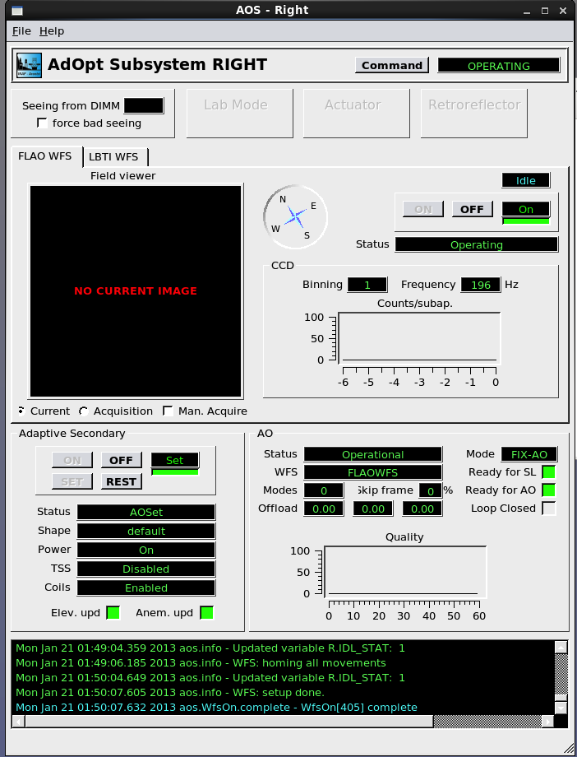

Figure 1: Screenshot of AOSGUI after successful completion of Procedure 3

# Check WFS functionality

This step is required to ensure the WFS unit is correctly working. It applies a board setup to send the beam from the internal source to the CCD39. There is no need of the retroreflector, the AdSec can be left in Safe mode, and the IRTC and the telescope are not needed. This procedure can be also used to check basic WFS functionality when the WFS is in the lab (provided the AGW unit is correctly powered, connected to the wfsdx computer and connected to cooling).

**Prerequisites:**

* Execute: Procedure 2 - Start and check Software status
* Execute: Procedure 3.2 - Power On FLAO WFS

|  |  |  |  |
| --- | --- | --- | --- |
|  | Action | Procedure | Notes |
|  | Setup WFS for internal check | Open terminal on wfsdx and write:  *[AOeng@wfsdx]$ runBoardSetup.py -load WUnitCheck* | There is no need for AdSec, retroreflector, IRTC, telescope. |
|  | Open CCD39 GUI | See Procedure 17.1 |  |
|  | Check illumination | You should see pupil images on the CCD39 GUI. See Figure 2 |  |

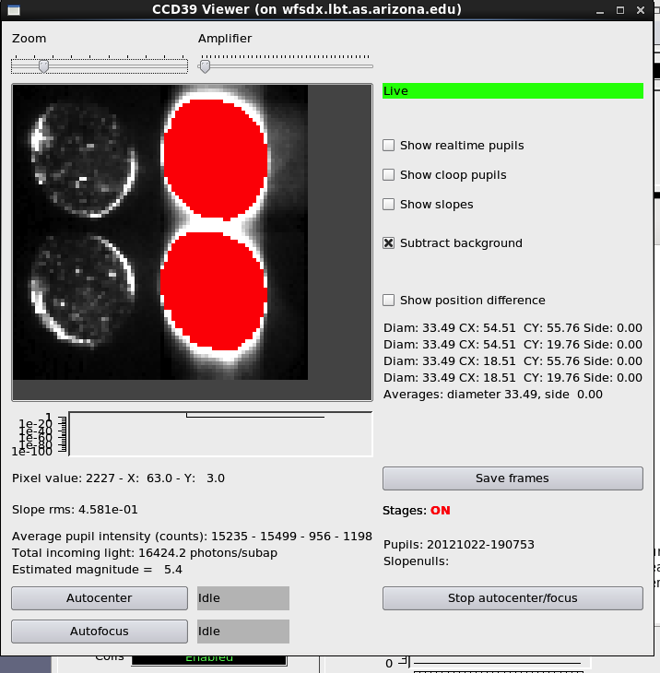 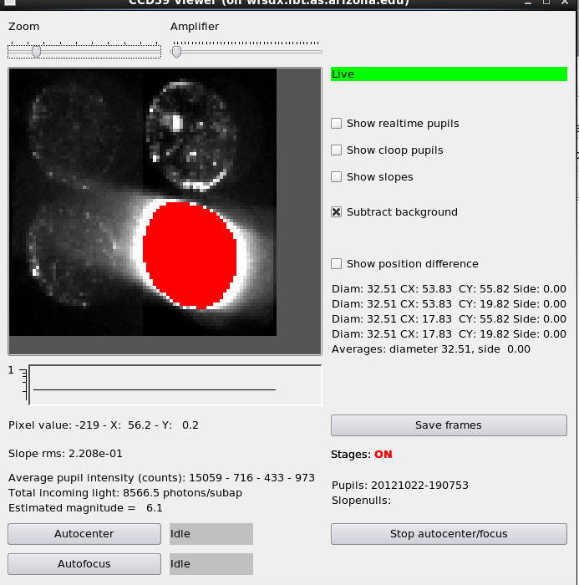

Figure 2 Example screenshots of CCD39 GUI at the end of Procedure 4

# Prepare WFS for night-time operation

This step is required to ensure that the WFS unit is ready for night-time operation after daytime checks have been completed. In essence, it shuts down the calibration lamp and ensures that the beam splitter cube is out of the optical path.

**Prerequisites:**

* Execute: Procedure 2 - Start and check Software status
* Execute: Procedure 3.2 - Power On FLAO WFS

|  |  |  |  |
| --- | --- | --- | --- |
|  | Action | Procedure | Notes |
|  | Setup WFS for night time operations | Open terminal on wfsdx and write:  *[AOeng@wfsdx]$ runBoardSetup.py –load calibUnitNight* | There is no need for AdSec, retroreflector, IRTC, telescope. |
|  | Open WFS Hardware GUI | See Procedure 17.1 |  |
|  | Check that calibration unit is off | Select “Power controller” in the left-hand panel. Check that “Flowerpot power” is Off (red), and that “Cube stage”, “Lamp” and “Cube rotator” are all Offline (yellow) like in the screenshot below. |  |

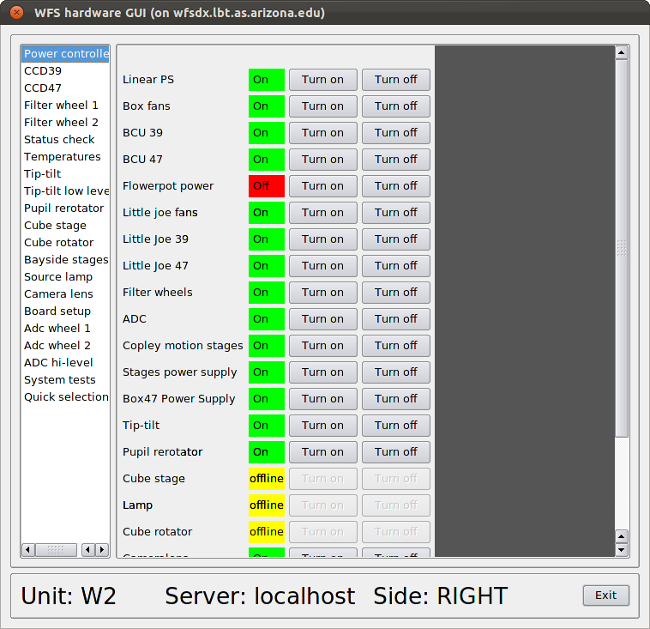

Figure 3: screenshot of WFS Hardware GUI with the calibration unit off.

# Operate the AO system in closed-loop in daytime

These procedures are needed to close the AO loop in daytime using the retroreflector. This is a basic functionality test to ensure that the AO system is correctly configured and working.

**Prerequisites:**

* Execute: Procedure 2 - Start and check Software status
* Execute: Procedure 3 - Start system and check hardware status
* (Optional, warmly suggested) Execute: Procedure 4 - Check WFS functionality

## Setup of telescope for daytime operation

|  |  |  |  |
| --- | --- | --- | --- |
|  | Action | Procedure | Notes |
|  | Install RetroReflector | Ask Telescope Manager **well** in advance |  |
|  | Authorize IRTC | See procedure 17.2 |  |
|  | Deploy swing arms | See procedure 17.2 |  |
|  | Home AGW probe | See procedure 17.2 |  |
|  | Set HBS on | Ask TO or Telescope Manager |  |
|  | Set stow-pins and activate elevation drive | Ask TO or Telescope Manager |  |
|  | Start rotator | Ask TO or Telescope Manager |  |
|  | Switch off light in the dome | Ask TO or Telescope Manager |  |
|  | Init Hexapod and set focal station | Ask TO or Telescope Manager, or follow this procedure:   1. Open OSSGUI (See Procedure 17.1) 2. Click on “Secondary (M2)” right 3. Press on Init button and wait approx 2min for homing. Wait for the “Mirror homed” indication turning green. 4. Click on “Tertiary (M3)” right and set the WFS focal station (i.e. bentGregorianFront) |  |
|  | Align hexapod | 1. Open PSFGUI2 (See Procedure 17.1) 2. Click on Disable button in the Lookup Table area. 3. Click on Disable button in the Temperature Correction area. 4. Click on every “Remove Corrections” button in PSFGUI2. 5. Insert Global Offset: look for last valid values in LBTO twiki, remember to press enter on each text area and finally press Update. 6. Check that the entered values are reflected in “Total Collimation“ and in “Hexapod Platform position” fields in the same gui. A small deviation is acceptable. | Move page with coordinates in the PUBLIC twiki |

## Setup of WFS for daytime operation

**Prerequisites:**

* Execute: Procedure 2 - Start and check Software status
* Execute: Procedure 3 - Start system and check hardware status
* (Optional, warmly suggested) Execute: Procedure 4 - Check WFS functionality

|  |  |  |  |
| --- | --- | --- | --- |
|  | Action | Procedure | Notes |
|  | Setup WFS unit for daytime operation | Open terminal on wfsdx and write:  *[AOeng@wfsdx]$ runBoardSetup.py –load calibUnitDay*  Wait for the prompt on the terminal. There is no visible feedback, a part for the pupil image disappearing from CCD39 GUI (if it is open). |  |

## Setup of IRTC for daytime operation

The IRTC software runs on a Windows computer which is accessed remotely using a “remote desktop” connection. Most IRTC optical parameters like field of view, filter, etc. must be configured manually using the Windows interface. In order to enable automatic frame acquisition from the AO software, the “irs” program must be up and running on the appropriate telescope computer.

The “irc” client program can be used to check the irs functionality. It can be run from any LBTO *obs* computer.

Note1: automatic image acquisition using the irc program or the AO system must be done with the camera live display OFF. If the live display is enabled while an image is taken, an error will occur.

Note2: this procedure contains a workaround (step 4) for a known bug in the IRTC code: the first image taken in automatic mode (that is, through irs) often fails. The solution is to take one or two images manually before starting any work.

**Prerequisites:**

1. IRTC installed, correctly connected. IRTC PC powered on.

|  |  |  |  |
| --- | --- | --- | --- |
|  | Action | Procedure | Notes |
|  | Start IRTC connection | On obsX terminal: *$startirtc*  Username: testcamera  Password: …  Kill old IRTC gui  Click on IRTC gui (icon on the desktop). | In case of errors (e.g. Error opening camera) try to restart the computer using the Window’s Task Manager. Wait 5 minutes and try to reconnect with *startirtc*  In case of long stops the IRTC PC in the lower-right treehouse could be off: switch it on. |
|  | Configure IRTC | Click Wide Field (even if already selected) and wait for  Select filter Empty (re-apply)  Set cooling to 240K and tick Enable  Set Exp time to 1000000 us (1s)  Enable live display (videocamera icon, “grab” tooltip),  Check that frame index in the status bar is running. | You will not see any spot on the camera at that stage, unless the system has been already aligned |
|  | Check “irs” functionality. | *lbt@obs3 % irc GetFilter*  Answer:  *Empty 0* | The current filter will be printed on screen. If any error occurs, ask telescope software group. |
|  | Test automatic acquisition | Disable live display (videocamera icon, “grab” tooltip).  *lbt@obs3 % irc GetImage*  Answer:  irtc.xxxx.xxxx.fits | The GetImage command replies with the FITS filename. If an error occurs, repeat the command a few times. |

## Retroreflector Alignment

**Prerequisites:**

* Execute: Procedure 3 - Start system and check hardware status
* (Optional, warmly suggested) Execute: Procedure 4 - Check WFS functionality
* Execute: Procedure 6.1 - Setup of telescope for daytime operation
* Execute: Procedure 6.2 - Setup of WFS for daytime operation
* Execute: Procedure 6.3 - Setup of IRTC for daytime operation

|  |  |  |  |  |  |  |
| --- | --- | --- | --- | --- | --- | --- |
|  | | Action | | Procedure | | Notes |
|  | Check spot in the IRTC | | If the PSF is already visible in the IRTC (actually you’ll probably see 2 spots) then you can skip the spiral-search and move to point 4- Center the spot | |  | |
|  | Align RetroReflector | | Open PSFGUI2 (See Procedure 17.1)  Set Global Offset Z to 0mm | |  | |
|  | Start spiral-search | | *[AOeng@adsecdx ~]$ aoidl*  *IDL> @startup-onlycom*  *IDL> print, hexa_spiral(500e-6, 15, /app)*  Now look carefully at the IRTC GUI to see the spot passing on the screen. Be careful and don’t distract yourself: it can take several minutes.  Positions are written in the terminal, an IDL plot is continuosly updated with the explored positions.  When you see the light in the IRTC stop the routine (Ctrl-C in IDL terminal) | |  | |
|  | Center the spot | | Modify the Global Offset in the PSFGUI2 to center the spot in the center (160,128 within +/- 7 pixels) of the IRTC field and to focus the image. You’ll see 2 spots because of a reflection. Choose the one on the **right**.  **Write down the Global Offsets: they will be needed next time to skip the spiral search**. | |  | |
|  | Coma correction | | See Procedure 17.6 - Coma correction | |  | |
|  | WFS stage centering | | See Procedure 17.3 - WFS stage centering | | This is likely not needed | |

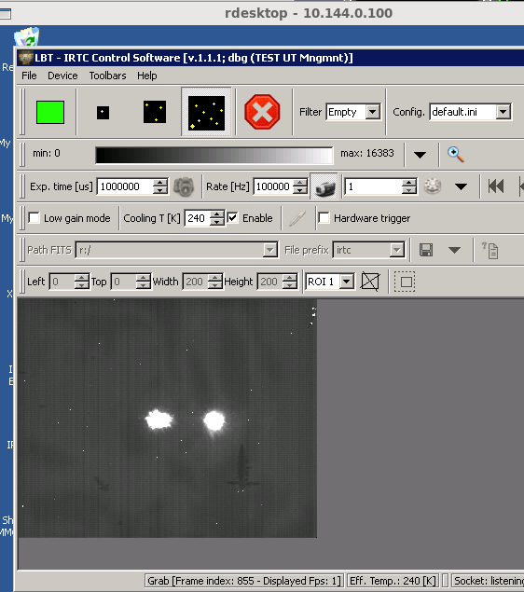

Figure 4 IRTC as it appears at the end of Procedure 6.4. **Note**: the right spot should be centered in the field, not the left one as shown in this picture.

## Close AO loop in daytime

**Prerequisites:**

* Execute: Procedure 6.4 - Retroreflector Alignment

|  |  |  |  |
| --- | --- | --- | --- |
|  | Action | Procedure | Notes |
|  | Enable RetroReflector Mode | On the Adsec terminal  *[AOeng@adsecdx]$ enable_rr_mode.sh*  Open AOSGUI (See Procedure 17.1)  In the AOSGUI the retroreflector led turns yellow | This is needed to prevent sending offloads to the M1. |
|  | Preset AO system | Open AOS Commands GUI (See Procedure 17.1)  In the PresetAO panel in the “AOS Commands” GUI set the following parameters:  AO mode = ACE-AO  WFS spec. = FLAOWFS  Ref Star X and Y = 0  Mag = 8  Color id = 0  Press “PresetAO” button  Wait (approx 2 min) for **Success** or **Failure** in the black text area close to the button. | WFS is preset. In the FLAO WFS panel of the AOS GUI binning and frequency are updated.  In case of failure look for HW errors in the log area in the AOS GUI. |
|  | Acquire Reference | Press AcquireRef button in the “AOS Commands” GUI  Wait for Success or Failure in the black text area close to the button |  |
|  | Cube angle fine-tuning | Open Wfs Arbitrator GUI (see Procedure 17.1).  In the “Loop params” panel enter the following parameters:  binning=1  Loop frequency=200 Hz  Modulation=20  And click the “Apply” button.  Open CCD39 GUI (See Procedure 17.1)  Open HW GUI (See Procedure 17.1)  Select “Cube rotator” in the left-hand panel of the HW GUI. Apply 0.1° **relative** movements (positive or negative) until the pupils are perfectly round and are not vignetted on either side. Good position is a no-change position. Typical offset wrt to default position is <0.3°. See Figure 5. | This is required in case of large temperature offsets and is due to a miscalibration in the cube rotator stage. The parameters with high modulation are needed to have a sharp pupil border. |
|  | Re-Acquire Reference | Execute points 2 and 3 of this procedure then move to point 6. |  |
|  | Close Loop | Press StartAO in the “AOS Commands” GUI. See Figure 6. |  |

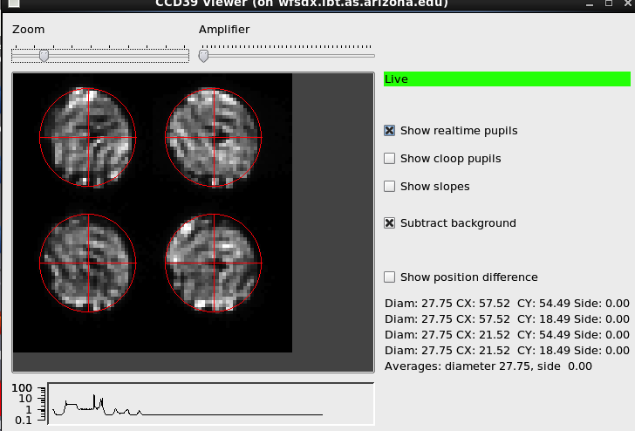

Figure 5 CCD39 GUI before cube angle fine-tuning. Pupils appear vignetted and are not perfectly round.

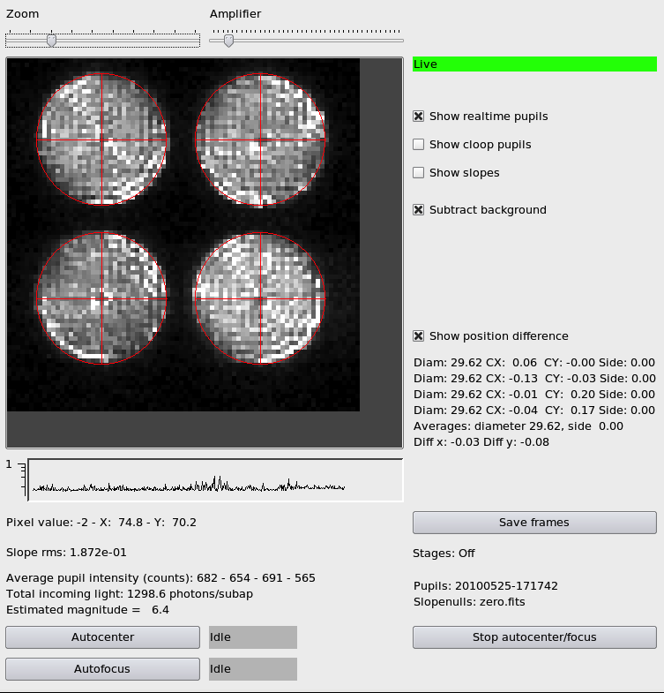

Figure 6 CCD39 GUI after cube angle fine-tuning and in closed loop

# Day-time IRTC closed-loop focus optimization

This procedure is needed to optimize focus on the instrument. In closed loop, the focus on the instrument is determined by the Z stage of the WFS board. For that, it is necessary to measure the optimal Z stage position to be used for each instrument configuration (filter and FoV). It is then responsibility of the Instrument Control software to set the WFS Z-stage to the measured values during on-sky operation.

**Prerequisites:**

* Execute: Procedure 6.5 - Close AO loop in daytime

|  |  |  |  |
| --- | --- | --- | --- |
|  | Action | Procedure | Notes |
|  | Move to IRTC small field | 1. Click small field in the IRTC GUI. You should see a defocused spot (see Figure 7) 2. Focus spot on the IRTC using OffsetZ in the “AOS Command” GUI 3. Select Filter H in IRTC 4. Center the spot in the IRTC field using OffsetXY “AOS Command” | OffsetZ command takes the **absolute** position as its argument. Range is from 0 to 50 mm.  OffsetXY is a **relative** movement. Typical values are +/- 0.2 mm. |
|  | Select IRTC Filter | Select IRTC filter in the IRTC GUI |  |
|  | Avoid saturation | Select IRTC Exposure time to have a peak value of 4000-5000 counts. |  |
|  | Start Focus Optimization | Start the GUI on wfsdx:  *[AOeng@wfsdx]$ AutoFocusIrtcGui.py*  Set the following parameter:  Focus Range: 2  Focus Step: 0.2  Images to average: 50  PSF position: coordinates of PSF spot in the IRTC detector (use IRTC status bar)  **NOTE: stop Live updating in the IRTC GUI**  Press Start button and wait. In the IRTC you can see the defocused spots. |  |
|  | Accept the results | The intensity vs Z postion plot is shown . The procedure is guessing what the best Z-stage position is by looking for the maximum in the plot. A window pops up asking to accept the found position: accept it.  If in the plot you don’t see a clear maximum, it is a safe approach to iterate the procedure from point 4.  IRTC image should look like the one in Figure 8 |  |
|  | Store the results | Write down the Z stage position together with the filter used. |  |

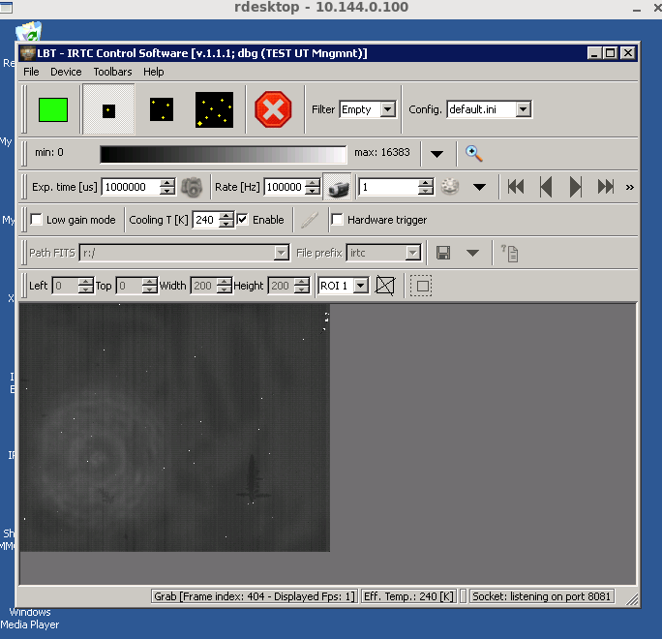

Figure 7 IRTC before tuning focus with "offset Z" command. This is the beginning of Procedure 7.

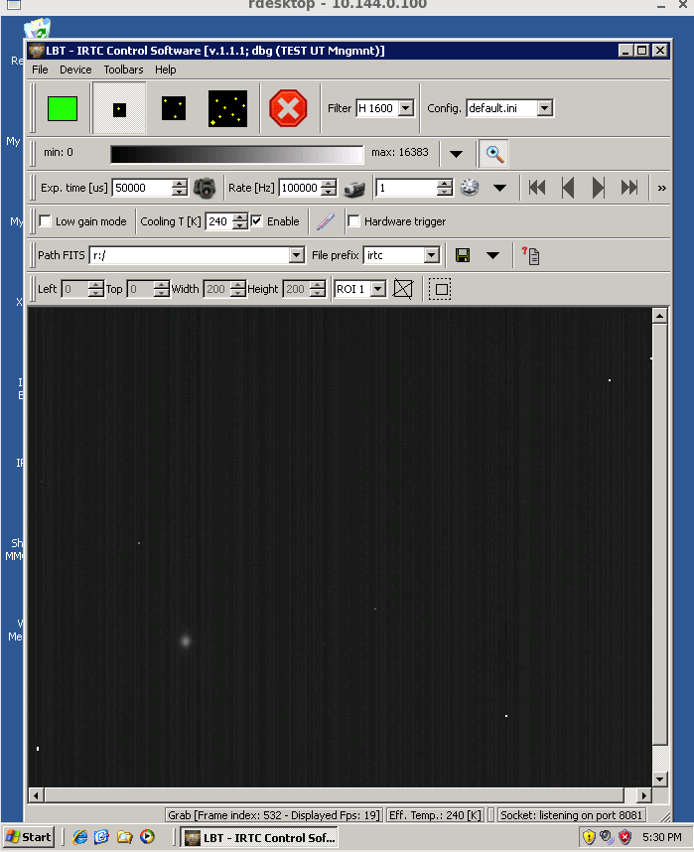

Figure 8 A well-focused PSF in closed-loop (H band, 3x2" FoV)

# Day-time IRTC closed-loop performance check

This procedure is needed to check closed-loop performance during day-time.

**Prerequisites:**

* Execute: Procedure 6.5 - Close AO loop in daytime
* Z-stage optimal position for the selected IRTC filter has been measured (see Procedure 7-Day-time IRTC closed-loop focus optimization)

|  |  |  |  |
| --- | --- | --- | --- |
|  | Action | Procedure | Notes |
|  | Move to IRTC small field | Select small field in the IRTC GUI  Select Filter H in IRTC  If needed, move the spot in the IRTC field using OffsetXY “AOS Command” in order to avoid hot pixels and stay at least 50 pixels from the frame edge. |  |
|  | Avoid saturation | Select IRTC Exposure time to have a peak value of 4000-5000 counts. |  |
|  | Check Acquisition script | In wfsdx edit the file */home/aoacct/acq/RR_irtc_psf*   1. Set the correct exposure time (e.g. “irtc 0.02” set exposure time to 20ms) 2. Set the number of frames to acquire (e.g. “image 500” acquires a cube of 500 IRTC frames). Hint: have 10s of total exposure time. Limit to 1000 frames. 3. Set the Z-stage position to the best-focus value determined in Procedure 7 (e.g. “offsetz 48.5”)   Save the file | This scripts acquire 3 cubes of IRTC frames + 1 cube of dark frames + 3 cubes of IRTC frames |
|  | Stop Live updating IRTC | Click on the videocamera button in the IRTC GUI. The frame counter in the status bar stops increasing. |  |
|  | Execute Acquisition script | At wfsdx terminal type:  *acq /home/aoacct/acq/RR_irtc_psf*  The script is executed. A set of measures is saved. Tracking numbers in the form YYYYMMDD_hhmmss (e.g. 20130122_180736) are written in the terminal.  Take note of the first one and of the last one. |  |
|  | Start elablib | See chapter 15.2 |  |
|  | Analyze the data | Use xelab. See chapter 15.2 |  |

# End of daytime work

Follow this procedure when the daytime activity is finished and you want to put the AO system in a safe state.

|  |  |  |  |
| --- | --- | --- | --- |
|  | Action | Procedure | Notes |
|  | Open AOSGUI | Open AOSGUI (See Procedure 17.1) |  |
|  | Switch off the WFS unit | Click on the OFF button in FLAO WFS panel |  |
|  | Rest the AdSec unit | Click on REST button in the Adaptive Secondary panel  **DO NOT power off the AdSec unit** |  |
|  | Close GUIs | Close all the GUIs |  |

# Store a flat

This procedure is needed periodically to store the best flat shape of the AdSec mirror. The procedure requires having the system in closed loop with very high degree of correction to have the best flat wavefront. The procedures records 10 seconds of diagnostic data and stores in the system the data needed to reproduce this mirror shape in the future.

Since AdSec position sensors may slowly get miscalibrated with the time, this procedure should be run periodically.

**Prerequisites:**

* Execute: Procedure 6.5 - Close AO loop in daytime

|  |  |  |  |
| --- | --- | --- | --- |
|  | Action | Procedure | Notes |
|  | Open AdSec Control GUI | Open AdSec Control GUI (See Procedure 17.1) |  |
|  | Enter flat name | Select “Shape Control” tab  In the “Save shape” edit box enter the name for the flat.  Chose a sensible name, possibly containing the date in the form YYYYMMDD. |  |
|  | Is this going to be the new default shape? | Is this going to be the new default shape for the AdSec Mirror? If yes, check “Set as default”. |  |
|  | Save data and store new file | Press Save and wait until “Execution Success” is written on top of the GUI (approx. 10s) |  |

# Readout noise measurement

This procedure performs an estimation of the electronic readout noise of the WFS CCD. The measurement also includes other sources of noise, such as dark current. Only the WFS needs to be powered on, and no requirement are set on other systems except for dark conditions in the telescope dome.

**Prerequisites:**

* Execute: Procedure 3.2 - Power On FLAO WFS

|  |  |  |  |
| --- | --- | --- | --- |
|  | Action | Procedure | Notes |
|  | Turn off all lights in the telescope dome | Ask TO or telescope manager |  |
|  | Ensure that WFS lamp is off | Open HW GUI (See Procedure 17.1)  Select “Source lamp” in the left-hand panel of the HW GUI.  Move the intensity slider to 0% (all the way to the left) |  |
|  | Start measurement | Select “System tests” in the left-hand panel of the HW GUI.  Click the “ccd39 RON AO TABLE test” button. |  |
|  | Save output | The measurement progress appears in the text box below the buttons. A resume is printed at the end and can be copied&pasted . See below for a screenshot with example values. |  |

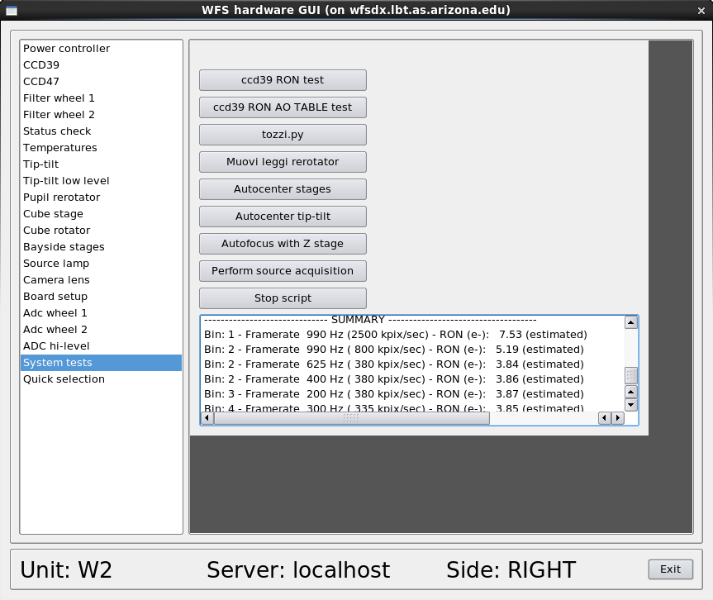

Figure 9: RON AO TABLE test output with good readout noise values.

# Day-time pupil wobble measurement

This measurement must be done with the AO loop closed, either with the retroreflector or on sky.

**Prerequisites:**

* Execute: Procedure 6.5 - Close AO loop in daytime

|  |  |  |  |
| --- | --- | --- | --- |
|  | Action | Procedure | Notes |
|  | Load 10 modes gain file. | Open AdSec Arbitrator GUI (See Procedure 17.1)  In the Gain panel of the Reconstructor tab, click the browse button and select the “0.1_10modi.fits” file. Click Apply | A low-order loop (10 modes only) will keep the loop stable while the pupil moves and rotates. |
|  | Slow down telescope derotator motion | Open telescope rotator panel (See Procedure 17.1)  In the rotator panel, click “Motion Ctrl”  In the “Persistent Parameters” panel, set the “Max Vel” to 1 deg/sec | This will allow the WFS rotator tracking to keep up with the derotator, which would be otherwise too fast. |
|  | Ensure rotator tracking is ON | Open the WFS Control GUI (see Procedure 17.1) and check that Telescope Rotator tracking is Enabled (green). If not, start it clicking the “On” button. |  |
|  | Open displays | Open the WFS Hardware GUI GUI (See Procedure 17.1) and select the “Camera lens” panel  Open the PSF GUI (see Procedure 17.1) and click on “Secondary” |  |
|  | Move telescope derotator to 0 degrees position | In the telescope rotator panel, enter 0 in the position box next to the “Slew to Hold” button  Press “Slew to Hold” button |  |
|  | Collect data | Note down:   * Telescope derotator angle * X and Y cameralens position * RX and RY thin shell offloads |  |
|  | Repeat measurement along a circle | Restart from step 5 at 30-degrees intervals (0, 30, 60…. 360) |  |
|  | Restore telescope derotator motion speed | Open telescope rotator panel (See Procedure 17.1)  In the rotator panel, click “Motion Ctrl”  In the “Persistent Parameters” panel, set the “Max Vel” to 5 deg/sec |  |

# Pupil wobble measurement using LEDs

It is possible to measure the pupil wobble using the secondary irror LEDs. This measure can be done at any time, provided that there is no light from any source on the WFS (either dome closed with lights off, or dome open on dark sky background).

**Prerequisites:**

* WFS is powered on (Procedure 3.2)

|  |  |  |  |
| --- | --- | --- | --- |
|  | Action | Procedure | Notes |
|  | Turn on the four LEDs. | Start aoidl on adsecdx:  *[AOeng@adsecdx ~]$ aoidl*  *IDL> @startup-onlycom*  *IDL> print, adam_led(0, /ON)*  *IDL> print, adam_led (1, /ON)*  *IDL> print, adam_led (2, /ON)*  *IDL> print, adam_led (3, /ON)* |  |
|  | Set loop parameters | Set loop parameters as described in 17.4 AO loop parameters | If LEDs are not visible on the ccd39, try reducing the frequency setting (values down to 50 Hz may be used.) |
|  | Ensure rotator tracking is ON | Open the WFS Control GUI (see Procedure 17.1) and check that Telescope Rotator tracking is Enabled (green). If not, start it clicking the “On” button. |  |
|  | Move telescope derotator to 0 degrees position | In the telescope rotator panel, enter 0 in the position box next to the “Slew to Hold” button  Press “Slew to Hold” button |  |
|  | Collect data | Use the Optical Loop GUI to save a tracking number with Frames enabled (see section 17.5 Saving AO telemetry) | Only the Frames checkbox is required. |
|  | Repeat measurement along a circle | Restart from step 5 at 30-degrees intervals (0, 30, 60…. 360) |  |
|  | Turn off the four LEDs. | Start aoidl on adsecdx:  *[AOeng@adsecdx ~]$ aoidl*  *IDL> @startup-onlycom*  *IDL> print, adam_led (0, /OFF)*  *IDL> print, adam_led (1, /OFF)*  *IDL> print, adam_led (2, /OFF)*  *IDL> print, adam_led (3, /OFF)* |  |
|  | Analyze data | Use the elab-lib to build a dataset with all the tracking numbers, and sum all the ccd39 frames together. |  |

# Preset table update

The AO preset uses a configuration table to select system parameters based on the reference star magnitude. Several such tables are available and one of them is selected using a file link. If one wants to change the AO table, the script “aotable.py” can be used as follows:

**Prerequisites:**

* System is NOT executing a Preset/RunAO command. No check is done, so this can break a preset if done at the wrong time.

|  |  |  |  |
| --- | --- | --- | --- |
|  | Action | Procedure | Notes |
|  | Start script | Open terminal on wfsdx and write:  *[AOeng@wfsdx]$ aotable.py* |  |
|  | Select one of the available tables | A list of tables is displayed with the currently used one evidenced. Enter the number corresponding to the new table and press Enter |  |
|  | Exit script | Enter a zero selection to exit the script. | Next preset will use the new table. |

Example output of the script with table #6 selected:

[AOeng@wfsdx scripts]$ aotable.py

choice : nmodes base rec filename

(*=current)

1 : 300 KL_v17 20130919_035723 table_IRTC_ACE-AO.badseeing.txt.fdm

2 : 300 KL_v16 20130919_035102 table_IRTC_ACE-AO.badseeing.txt.newpup

3 : 300 KL_v16 20130915_224932 table_IRTC_ACE-AO.badseeing.txt.orig

4 : 400 KL_v16 20130915_224932 table_IRTC_ACE-AO.goodseeing.txt

5 : 400 KL_v17 20130919_024505 table_IRTC_ACE-AO.goodseeing.txt.fdm

6 * : 400 KL_v16 20130919_014135 table_IRTC_ACE-AO.goodseeing.txt.newpup

7 : 5 KL_v7 20101028_110316 table_IRTC_TTM-AO.txt

Enter choice (0 = exit program)

# PISCES tasks

## Focusing

An engineering procedure is available to automate the task of focusing the PISCES camera. This procedure is provided for convenience only and, since it relies on undocumented communication between the FLAO and PISCES software, it should not be expected to be available indefinitely.

**Prerequisites:**

* System is in closed loop with the PISCES camera online

|  |  |  |  |
| --- | --- | --- | --- |
|  | Action | Procedure | Notes |
|  | Check shared disk | On WFS computer  *[AOeng@wfsdx ~] ls /mnt/newdata*  If it is empty, then the shared disk is not mounted:  *[AOeng@wfsdx ~] sudo mount /mnt/newdata* |  |
|  | Start GUI | On WFS computer:  *[AOeng@wfsdx ~] AutoFocusPiscesGui.py* |  |
|  | Enter parameters | Focus range and step are in mm.  PSF position on Pisces (x,y) may be approximate up to about 10 pixels and can be seen using ds9. |  |
|  | Start measurement | Press “Start” to start the focus script. The Z stage will be moved in successive focus positions, and at each step a cube of Pisces images will be taken |  |

## Telemetry synchronization

Storage of AO telemetry data is synchronized with the Pisces camera: each time a Pisces image is taken, a tracking number is saved at the beginning of the Pisces acquisition. The tracking number contains about four seconds of telemetry data.

Start/stop synchronization:

|  |  |  |  |
| --- | --- | --- | --- |
|  | Action | Procedure | Notes |
|  | Start system processes GUI | See procedure 17.1. |  |
|  | Start or stop synchronization process. | Locate the process called “Pisces telemetry sync” and start/stop as needed. |  |

Data is saved at each Pisces image acquired with the observe script. No message is displayed.

Synchronization is active by default.

# Example Use of elablib

The following routines are needed to start the *elablib* and execute the basic commands to analyze a measurement.

The xelab GUI is meant to provide a quick visualization of the information.

The elablib routines can be used at IDL prompt for deep analysis and scripting of the analysis procedures. They require an deep knowledge of object-oriented IDL. They are meant to be used by developers and AO experts to analyze AO performances with scripts.

|  |  |  |
| --- | --- | --- |
| Action | Procedure | Notes |
| Start *elablib* | Open a terminal on adsecdx: *ssh -X AOeng@adsecdx*  Start idl: *[AOeng@adsecdx ~]$ aoidl*  Init elablib: *IDL> ao_init* |  |
| Start *xelab* | From a running elablib  *AO> xelab*  Select the date in the left-hand panel.  The log of all the measurements of the selected date is printed.  Select a single measure: most significant values are shown, together with the PSF and a plot of modal amplitudes. | elablib and xelab GUI are under continuous development. |
| *elablib* help | From a running elablib, suppose you need to analyze in detail a single measurement (e.g. 20130122_180545) because you want to check the rerotator angle.  Load the measure  *AO> ee=getaoelab('20130122_180545')*  Ask to the help with a sensible hint:  *AO> ee->help, 'rotat'*  In the list of help entries containing the token ‘rotat’ select the one about rerotator and print the value  *AO> print, (ee->wfs_status())->rerotator()*  *179.99899* |  |

# Miscellaneous

The following procedures are either widely used or seldom needed.

## Start GUIs

|  |  |  |
| --- | --- | --- |
| Action | Procedure | Notes |
| Open AOS GUI | Log on obs3  Open terminal  Type: AOSGUI right | user: lbto  pwd: OPSin2010 |
| Open AOS Commands GUI | Open AOSGUI (see above)  Press the Command button (top-right) |  |
| Open WFS Arbitrator GUI | Open wfseng panel from wfsdx terminal  *[AOeng@wfsdx ~]$ wfseng*  Click on “WFS Arbitrator GUI” button wfseng panel |  |
| Open WFS Hardware GUI | Open wfseng panel from wfsdx terminal  *[AOeng@wfsdx ~]$ wfseng*  Click on “WFS HW GUI” button on wfseng panel |  |
| Open CCD39 GUI | Open WFS Arbitrator GUI (see above)  **NB Only if it has not been done before, set loop parameters:**  In “Loop params” panel of “WFS Control GUI” set   * Binning=1, * Loop frequency=200Hz, * Modulation=3   Click Apply  Click on “WFS camera“ blue button |  |
| Open AdSec Control GUI | Open adsceng panel from adsecdx terminal  *[AOeng@adsecdx ~]$ adsceng*  Click on “AdSec Control GUI” button on adsceng panel |  |
| Open PSFGUI2 | Log on obs3  Open terminal  Type: PSFGUI right  Click on Secondary button: the *“Right PSF Secondary Mirror Active Optics and Collimation Control”* GUI (PSFGUI2) is opened |  |
| Open telescope rotator panel | Log on obs3  Open terminal  Type: MCSGUI right  Click on Rotators button and then on Right Front |  |
| Open IIF GUI | Log on obs3  Open terminal  Type: IIFGUI right |  |
| Open OSS GUI | Log on obs3  Open terminal  Type: OSSGUI |  |

## Check and set Telescope configuration

These procedures are needed to check the telescope configuration

|  |  |  |
| --- | --- | --- |
| Action | Procedure | Notes |
| Check Authorized Instrument | Open IIFGUI  In the top right (left) text area you see the authorized instrument and focal station  Ask the TO / telescope manager if it is not what you needed |  |
| Check Swing Arms | Open OSSGUI  Click on one of the swing arm icons on the right side  In the “Secondary (M2)” panel check the “Dep. Switches” status. It should be “Dep”. If it is not, ask the TO/Telescope Manager to deploy it.  In the “Tertiary (M3)” panel check the “Dep. Switches” status. It should be “Dep”. If it is not, ask the TO/Telescope Manager to deploy it. |  |
| Home AGW probe | Ask the TO/Telescope Manager. Hint:  At the telescope@AGW prompt at TO console type:  home –u 2 –m 21 |  |

## WFS stage centering

This procedure might be needed only when the instrument has been reinstalled. Be sure that this is actually needed.

THIS IS NOT COMPLETED

|  |  |  |  |
| --- | --- | --- | --- |
|  | Action | Procedure | Notes |
|  | Open WFS HW GUI |  |  |
|  | Setup CCD47 | In the HW GUI, select CCD47 panel |  |
|  |  | Open WFS Control GUI and click on “Acquire TV dark” |  |

## AO loop parameters

Standard loop parameters for calibration tasks can be set as follows:

|  |  |  |  |
| --- | --- | --- | --- |
|  | Action | Procedure | Notes |
|  | Open Wfs Arbitrator GUI |  |  |
|  | Set loop parameters | In the “Loop params” panel, set the following parameters:   * Binning=1 * Loop frequency= 200 Hz * Modulation = 3   And click “Apply” | A dark will be takn, a flashing display is normal while this happens. |

## Saving AO telemetry

Telemetry data is continuously generated by the AO system, but it is not stored on disk due to the huge space required. The operator can request that the next N telemetry frames are stored on disk. This data will be saed intoa “tracking number”, which is a timestamp in the format YYYYMMDD_HHMMSS. Each tracking number is a sequence of continuous data, typically a few seconds long. A directory is created for each tracking number, containing a number of FITS files.

The GUI for requesting saving of tracking numbers is called “Optical loop diagnostic GUI”. It can be started from the wfseng panel as described in 17.1 Start GUIs, or from a terminal on wfsdx typing OptLoopDiagnGui”.

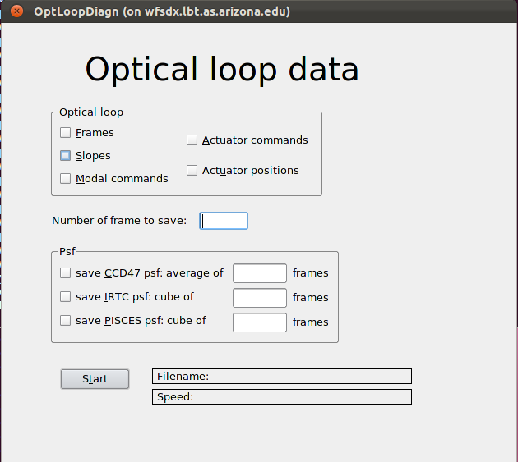

**Prerequisites:**

* WFS must be powered on. As a minimum, ccd39 must be on and operating. If other WFS devices are off, telemetry data will be saved but may be incomplete.

**Required fields:**

* **Number of frames to save**: typical numbers range from 4000 to 10000. As a rule of thumb, the system saves 500 frames per second at full speed, and progressively less down to 100 per second when the AO loop is running slowly on faint stars. The maximum number is limited by the memory available on the PC, and is around 50000.

**Optional fields:**

* Frames: save ccd39 frames
* Slopes: save slopes calculated from ccd39 frames.
* Modal commands: modes as calculated by the ASM. Will be zero unless the system is in closed loop.
* Actuator commands: commands sent to ASM actuators. Will be zero unless the system is in closed loop.
* Actuator positions: ASM actuator positions. Will be zero unless the system is in closed loop.
* PSF checkboxes: will read N frames from various detectors, average them and save the result on disk. Take care of only selecting those detectors that are on and available, otherwise an error will occur. Note: PSFs are saved in parallel with telemetry. Long averages of PSF data may take much longer than telemetry data to finish, in that case the tracking number will be considered complete only when the PSF has finished.

Usage:

Fill in the required fields, any optional fields and click on Start: the tracking numbers will be immediately displayed in gray, along with the current telemetry speed. When completed, the tracking number will turn green. In case of any error, the tracking number display will turn red with an “Error “ string.

Result:

When the tracking number is completed, a directory with YYYYMMDD_HHMMSS format has been created in the data repository. Inside the directory, these files can be found:

* wfs.fits: a FITS file with no data and a header with the complete WFS status and configuration
* adsec.sav: a similar file for the ASM status, but in IDL .SAV format
* other fits files: telemetry data. Many files are only optionally saved.

## Tracking number data is best analyzed with elab-lib (see section 15.2 Telemetry synchronization

Storage of AO telemetry data is synchronized with the Pisces camera: each time a Pisces image is taken, a tracking number is saved at the beginning of the Pisces acquisition. The tracking number contains about four seconds of telemetry data.

Start/stop synchronization:

|  |  |  |  |
| --- | --- | --- | --- |
|  | Action | Procedure | Notes |
|  | Start system processes GUI | See procedure 17.1. |  |
|  | Start or stop synchronization process. | Locate the process called “Pisces telemetry sync” and start/stop as needed. |  |

Data is saved at each Pisces image acquired with the observe script. No message is displayed.

Synchronization is active by default.

Example Use of elablib)

## Coma correction

After the first alignment, the spot will most likely show a big coma aberration. This can be removed with a “move on sphere” command to the hexapod. To apply a coma of magnitude C, an **offset** must be applied to both the **current** X position and RY tilt of the hexapod (or Y position and RX tilt):

* deltaX = +C * 10microns
* deltaRY= +C arcsec

To correct coma along the other axis:

* delta Y= +C * 10 microns
* delta RX = -C arcsec

Note the minus sign on the RX field

It is best to start correcting the coma on one axis and, when the coma bar has become vertical (or horizontal), correct on the other axis. A couple of iterations might be needed.

|  |  |  |  |  |  |  |
| --- | --- | --- | --- | --- | --- | --- |
|  | | Action | | Procedure | | Notes |
|  | Open PSFGUI2 | | Open PSFGUI2 (See Procedure 17.1) | |  | |
|  | Correct Coma | | Modify Global Offsets ( see above) until PSF looks ok. | |  | |

# 

# Maintaining this document

Please report any mistake / comment / suggestion to [lbusoni@arcetri.astro.it](mailto:lbusoni@arcetri.astro.it)

Doc_info_start

Title: FLAO user procedures

Document Type: Technical Report

Source: INAF-Osservatorio Astrofisico di Arcetri

Issued by: Lorenzo Busoni, Alfio Puglisi, Juan Carlos Guerra, Enrico Pinna, Simone Esposito

Date_of_Issue:

Revised by:

Date_of_Revision:

Checked by:

Date_of_Check:

Accepted by:

Date_of_Acceptance:

Released by:

Date_of_Release:

File Type:MS-WORD

Local Name:

Category: WRITE THE CAN CATEGORY HERE

Sub-Category: WRITE THE CAN SUB-CATEGORY HERE

Assembly: WRITE THE CAN ASSEMBLY HERE

Sub-Assembly:

Part Name:

CAN designation: nnnfnnn

Revision:

Doc_info_end