LBT Adaptive Secondary Mirror. Functional Description
M. Xompero, L. Busoni, D. Zanotti, A. Riccardi

(1) INAF-Osservatorio Astrofisico di Arcetri
ABSTRACT
This document is a detailed description of the functionalities of the LBT adaptive secondary mirror sub-system. It defines the possible statuses of the unit and the procedures and rules to switch among them in interaction with the AO-Supervisor.

Modification Record
Version | Date | Author | Section/Paragraph  affected | Reason/Remarks
1.0 | 10 Giu 2005 | A. Riccardi | All | First release of the document
2.0 | 15 Gen 2006 | L. Busoni, M. Xompero | All | Added description of states, events and actions
2.2 | 02 Feb 2006 | D. Zanotti | IDL procedures | Added description of IDL routines
2.3 | 23 May 2006 | L.Busoni | All | Introduction reviewed and minor changes
2.4 | 23 May 2007 | M.Xompero | All | Added Fault cases analisys
3.0 | 30 Jan 2017 | M. Xompero | All | Updated with last code issue (UAO)
3.1 | 15 Feb 2017 | A. Puglisi | 3, 3.5.1

Abbreviations, acronyms and symbols
Symbol | Description
AdSecArb | Adaptive Secondary Arbitrator
AOA | Adaptive Optics Arbitrator
AO-System | The hardware and software components of the LBT first light Adaptive Optics System.  Includes the Wave-Front Sensor, the Adaptive Secondary Mirror, the AO Computer and some auxiliary devices (such as networking hardware).
AO-Supervisor | The software system which manages all the components of the AO-System
AOS | Adaptive Optics Subsystem, a part of TCS devoted to interaction with the AO-Supervisor
APS | Auxiliary Power Supply
ASM | Adaptive Secondary Mirror
BCU | Basic Communication/computational Unit (board)
DSP | Digital Signal Processor
FSM | Finite State Machine
FST | ASM fast diagnostic. It is a module of AO-Supervisor
GUI | Graphical User Interface
HSK | ASM housekeeper diagnostic. It is a module of AO-Supervisor
LBT | Large Binocular Telescope
LBT672 | LBT Adaptive Secondary Mirror Unit
MCB | Manual Circuit Breaker
MPS | Adaptive Secondary Main Power Supplies
SIGGEN | Signal Generation (board)
TBD | To Be Defined / To Do
TCS | Telescope Control System
TSS | Thin shell Safety System
WFS | Wave Front Sensor
WFSArb | Wave Front Sensor Arbitrator

Contents
1 Introduction 4
1.1 Events 5
2 Fault cases – SECTION REMOVED 6
3 LBT672 States 6
3.1 Manual-Breaker-off state 6
3.1.1 Transition events from Manual-Breaker-off state 6
3.2 Power-off state 7
3.2.1 Transition events from Power-off state 7
3.3 Power-on state 7
3.3.1 Transition events from Power-on state 7
3.4 Diagnostics common events 7
3.5 Rest state 8
3.5.1 Transition events from Rest state 8
3.6 AOSet state 8
3.6.1 Transition events from the Set/SL state 8
3.7 AORunning state 9
3.7.1 Transition events in AORunning state 9
3.8 AOPause state 9
3.8.1 Transition events in AOPause state 9
3.9 Failure state 9
3.9.1 Transition events in Failure state 9
3.10 Panic state 9
3.10.1 Transition events in Panic state 9
4 IDL procedure interface for actions 11
4.1 fsm_power_on 11
4.2 fsm_load_program 11
4.3 fsm_reset 11
4.4 fsm_power_off 12
4.5 fsm_set_flat 12
4.6 fsm_switch_state 13
4.7 fsm_rest 14
4.8 fsm_fault_recovery 14
4.9 fsm_set_gain 15
5 References 15

Introduction
This document is a detailed description of the functionalities of the LBT adaptive secondary mirror sub-system (LBT672). It defines the possible statuses of the unit and the procedures and rules to switch among them in interaction with the AO-Supervisor. The system excludes the hexapod, which is under direct control of the TCS.
For what concerns this document, the system is composed of the following logical components (see Figure 1):

Adaptive Secondary Arbitrator (AdSecArb): This is the server process that listens for the requests of change of state and calls the appropriate routines on IDLcontroller, Housekeeper and FastDiagn.
IDLController: This process executes the IDL procedures described in section 4 on request of AdSecArbitrator,
Housekeeper (HSK) This is a diagnostic process that monitors the status of the on-board electronic devices. It has access to data like voltages and currents of the power supplies, temperatures, air pressure and humidity.
AdamHousekeeper (AHSK) This is a diagnostic process that monitors the status of MOXA device signals.
FastDiagn (FST) This is a diagnostic process that monitors the status of the shell. It has access to data like actuators position and forces.
Adaptive Optic Arbitrator (AOA): An AO-Supervisor module that routes requests from the TCS (via AOS) to AdSecArb and WFSArbitrator and vice versa. The AOA interprets the commands issued by the TCS and requests the necessary actions to both the WFSArbitrator and the AdSecArb. AOA also acts as communication path between WFSArb and AdsecArb. Finally, AOA routes the messages directed from LBT672 to AOS.
Adaptive Optic Subsystem (AOS): A TCS subsystem that acts as a bridge between TCS and the AO-Supervisor; it listens to the commands from the other TCS subsystems and send the appropriate request to AOA.
Wave-Front Sensor Arbitrator (WFSArb): The counterpart of AdSecArb for the Wave-Front Sensor unit.

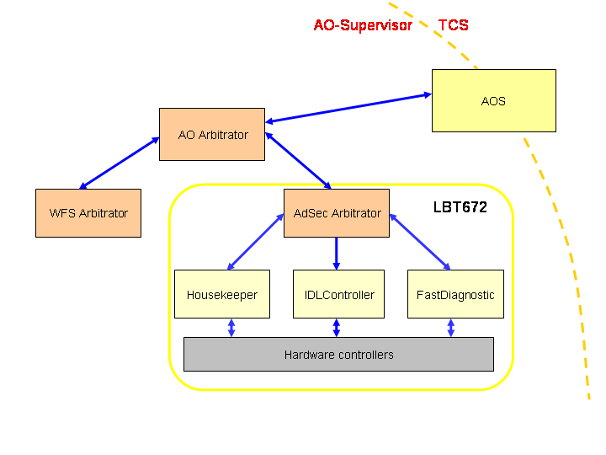
Figure 1 Adaptive Optic Arbitrators hierarchy

Events
The following events are notified to AdSecArb through AOA by external components (AOS, engineering GUIs, AOA itself):

Switch-State: REMOVED
Calibrate: REMOVED
Apply-Modes: REMOVED
Power-off Request a system shutdown
Power-on Request a system power up
Reset Request a system reset
Set&Flat Request a mirror set
LoadShape Request a new shape for the mirror
LoadRec Performs a new reconstructor upload
ApplyCmd Apply new commads to the mirror actuators
CorrectModes Apply new zernike modes to the mirror
RunAO Configure the system for AO operations
SetGain Change AO loop gain
PauseAO Pause AO loop
ResumeAO Resume AO loop
StopAO Stop AO loop operation
Rest Put mirror in REST state
FaultRecovery Try to recover from a failure.
Load shape: Request a new shaper for the mirror
Set-Gain: Request an update of the gain of the optical loop.
Emergency-shutdown: Sent by AOA in case of emergency caused by something external to LBT672. Hence the system does not go in Error state.

The following pathological events are generated internally at LBT672:
AdamHousekeeping-Alarm Sent by AHSK in case of wrong signals on MOXA. Just log.
Housekeeping-Warning Sent by HSK in case of values of temperature, currents, voltages and the like outside of normal ranges but not immediately dangerous for the system.
Housekeeping-Alarm Sent by HSK in case of dangerous values of temperature, currents, voltages and the like requiring immediate reaction.
FastDiagnostic-Warning Sent by FST in case of values of actuator position, forces and shell stress outside of normal ranges but not immediately dangerous for the system.
FastDiagnostic-Alarm Sent by FST in case of dangerous values of actuator position, forces and shell stress requiring immediate reaction.

Fault cases – SECTION REMOVED

LBT672 States
The complete Finite State Machine (FSM) diagram of LBT672 is shown in Figure 2. Table 1 lists the events caught in a given state. In the following each state is described in detail together with the transition events and actions that bring the system out of a given state.

Event | PowerOff | Ready | AOSet | AORunning | AOPause | Failure | Panic
Manual-Breaker-off
Power-off |  | x |  |  |  | x | x
Power-on | x
Reset |  | x | x
Set&Flat |  | x
LoadShape |  |  | x
LoadRec |  |  | x
ApplyCmd |  |  | x
CorrectModes |  |  | x
RunAO |  |  | x
SetGain |  |  | x | x
PauseAO |  |  |  | x
ResumeAO |  |  |  |  | x
StopAO |  |  | x | x | x
Rest |  |  | x |  | x
FaultRecovery |  |  |  |  |  | x
Table 1: State-Events table

The Ready state is intended for long-term standby: electronics is on, but the shell is not set. This state corresponds to the SAFE display on the AOS GUI.

The state is managed by the IDL controlling process. Whenever an IDL procedures that implements a transition completes successfully, the IDL process changes the current state. This state is reflected into MsgD variables (ADSEC.<side>.FSM_STATE) and is read by the AdSec arbitrator in order to decide which commands can be accepted at a given moment. The AdSec ICE interface makes the state available as well.

Manual-Breaker-off state
In this status the Manual Circuit Breaker (MCB) [Ref 1, par13] is off. No power is supplied to the Ethernet switch, so there is no way to switch on the power supplies of LBT672 (remotely managed through the Ethernet controlled digital I/O).

Transition events from Manual-Breaker-off state
Breaker-on event: [Breaker-on action] The Breaker is manually switched on by the operator. The event triggers the Manual-Breaker-on action for the transition to the Power-off state.

Power-off state
In this status the MCB is on. The Auxiliary Power Supply (APS) is switched on. The Ethernet switch and the Ethernet controlled digital I/O are powered by APS and are correctly working. Adaptive secondary Main Power Supplies (MPSs) are switched off.

Transition events from Power-off state
Power-on event: [Power-on action] AO-Supervisor switch on the ethernet power controller. Check that firmware has correctly bootstrapped. ASM housekeeping diagnostic (HSK) is started. Prerequisites: AO software is running. IDL function: fsm_power_on.pro
Breaker-off event: [Breaker-off action] The Breaker is manually switched off by the operator. The system goes in the Manual-Breaker-off state.

Power-on state
In this status the MPSs are switched on. The LBT672 crates have power. The BCU, SIGGEN, DSP boards and Power Backplane (PBP) firmware has correctly bootstrapped. Diagnostic communication is properly working. DSPs are in idle waiting for program uploading. Housekeeping diagnostic (HSK) is running and the related GUI is available. The shell is pushed against the reference plate by the bias magnets. Coils are disabled.

Transition events from Power-on state
Load-Program event: [Load-Program action] Communication with DSP memories is tested. DSP program is uploaded. DSP memories are initialized. The default configuration is loaded. DSP program is started. Communication with DSP memories is tested again. ASM fast diagnostic (FST) is started. The functionality of coils, current drivers and capacitive sensors is checked. Dust contamination is checked. On successful completion of this action the system is in the Rest state. IDL function: fsm_load_program.pro
Power-off event: [Power-off action] AO-Supervisor switch off the ethernet power controller. HSK is stopped. The system goes in Power-off state. IDL function: fsm_power_off.pro
Housekeeping-Warning event: [Housekeeping-Warning action]: Notify the anomaly to the AOS. The system remains in the present state.
Housekeeping-Alarm event: [Housekeeping-Alarm action]: If needed, push back the shell against the reference plate + see [Power-off action] + dump diagnostic status in the TCS log system + notify the AOS an emergency shutdown. The system goes in Unrecoverable Error state (Error: Reference source not found).
Emergency-shutdown event: [Emergency-shutdown action]: If needed, push back the shell against the reference plate + [Power-off action]

Diagnostics common events
For the states REST, AOSet, AORunning, the diagnostics behave in the same way as described here:
AdamHousekeeping-Alarm event:[AdamHousekeeping-Alarm action]: Notify the anomaly.
Housekeeping-Warning event: [Housekeeping-Warning action]: Notify the anomaly to the AOS. The system remains in the present state.
Housekeeping-Alarm event: [Housekeeping-Alarm action]: If needed, push back the shell against the reference plate + see [Power-off action] + dump diagnostic status in the TCS log system + notify the AOS an emergency shutdown.
FastDiagnostic-Warning event: [FastDiagnostic-Warning action]: Notify the anomaly to the AOS. The system remains in the present state.
FastDiagnostic-Alarm event: [FastDiagnostic-Alarm action]: If needed, push back the shell against the reference plate + dump diagnostic status in the TCS log system + notify the AOS a service break.
Emergency-shutdown event: [Emergency-shutdown action]: If needed, push back the shell against the reference plate + [Power-off action]

Rest state
In this state the DSP program is uploaded and running. The configuration for the default shell-to-refplate gap is loaded. Coils and current driver have been tested. Capacitive sensors have been tested. No significant dust contamination has been detected. ASM fast diagnostic (FST) and HSK are running and the related GUIs are available. The shell is pushed against the reference plate by the bias magnets. Coils are disabled. The LBT672 unit is ready for running calibration and engineering test procedures on AO-Supervisor request and it is ready for loading the configuration related to the operative mode that will be selected by the TCS through the AOS. This is the end-state of a successful default start-up procedure.

Transition events from Rest state
Reset event: [Reset action]: Firmware is reset and checked. The system goes in Power-On state IDL function: fsm_reset.pro.
Set&Flat event: [Set&Flat action]: Clear history of currents, commands, modes and the like on DSP memory. The configuration parameters corresponding to the operating mode selected by the AOS are loaded (feed-forward matrices, shell-to-reference-plate gap, flattening positions, reconstructor parameters and the like). Parameters and thresholds of FST are updated. Coils are enabled. The mirror shell is set as floating and flattened. During this action, the operator must make sure that there are no fast motions of the telescope and of the hexapod: there is no communication from the AO system to the TCS regarding this. The system goes in AOSet state. IDL function: fsm_set_flat.pro

AOSet state
In this state the LBT672 unit has loaded successfully the configuration parameters.
The mirror shell is set as floating. ASM fast and housekeeping diagnostics are running and the related GUIs are available. The internal integrator of control forces is active and triggered by an internal clock (period no shorter then 10ms). The telescope and hexapod can be safely moved for re-pointing in this state. ASM doesn’t require WFS services to run in this state.

Transition events from the AOSet state
Rest event: [Rest action]: The shell is sucked back against the reference plate in a smooth way. Parameters and thresholds of FST are updated. The system goes to the Rest state. IDL function: fsm_rest.pro
LoadRec event: [LoadRec action]: Upload configuration of the new reconstructor. Parameters and thresholds are updated. During this action, TCS must prevent fast motion of the telescope and of the hexapod and no external commands can be given to the ASM. The system remains in the AOSet state.
LoadShape event: [LoadShape action]: Load and apply a new shape to the mirror by resetting the previous settings and computing new flat commands. The system remains in the AOSet state. IDL function: fsm_load_shape.pro
ApplyCmd event: [ApplyCmd action]: apply a new commands to the mirror. IDL function fsm_apply_cmd.pro.
CorrectModes event: [CorrectModes action]: apply a new zernike modes to the mirror. IDL function fsm_correct_modes.pro.
RunAO event: [RunAO action]: Parameters and thresholds of FST are updated. The fast link between WFS and ASM is enabled by the WFS. The update of internal integrator of control forces, and slopes, modes and feed-forward-forces calculation are triggered by the WFS. The system goes to the AORunning state. IDL function: fsm_run_ao.pro

AORunning state
In this state the LBT672 unit is accepting commands to modify the shell shape while the system is monitored via fast and housekeeping diagnostics. Optical loop with WFS is closed and ASM accepts commands only from the WFS.

Transition events in AORunning state
StopAO event: [StopAO action]: The system goes back to the Set/AO state. IDL function: fsm_stop_ao.pro
SetGain event: [SetGain action]: Change the gain of the optical loop. IDL function: fsm_set_gain.pro
PauseAO event: [PauseAO action]: The system temporary stop to receive the optical loop commands. IDL function: fsm_pause_ao.pro

AOPause state
In this state the LBT672 unit is accepting only the command to restore the AO loop. Optical loop with WFS is opened and ASM keeps the current mode application.

Transition events in AOPause state
ResumeAO event: [ResumeAO action]: The system goes back to the AORunning state. IDL function: fsm_resume_ao.pro
StopAO event: [StopAO action]: see 3.7.1

Failure state
This is a temporary state in which the system status is unknown and some event triggered a diagnostics reaction. The state is temporary because a service procedure is called and, according to the UAO document, the event is marked as recoverable or unrecoverable. In the first case, the system is reset and there is an attempt to go to Rest state. In the second case the system goes into Panic state.

Transition events in Failure state
FaultRecovery event: [FaultRecovery action]: The system goes back to the Rest state. IDL function: fsm_fault_recovery.pro
Power-off event: see 3.3.1

Panic state
In this state the system is waiting for human intervertion. The software is not able to recovery by itself. No advanced actions are allowed.

Transition events in Panic state
PowerOff event: [FaultRecovery action]: The system goes back to the Rest state. IDL function: fsm_fault_recovery.pro
Power-off event: see 3.3.1

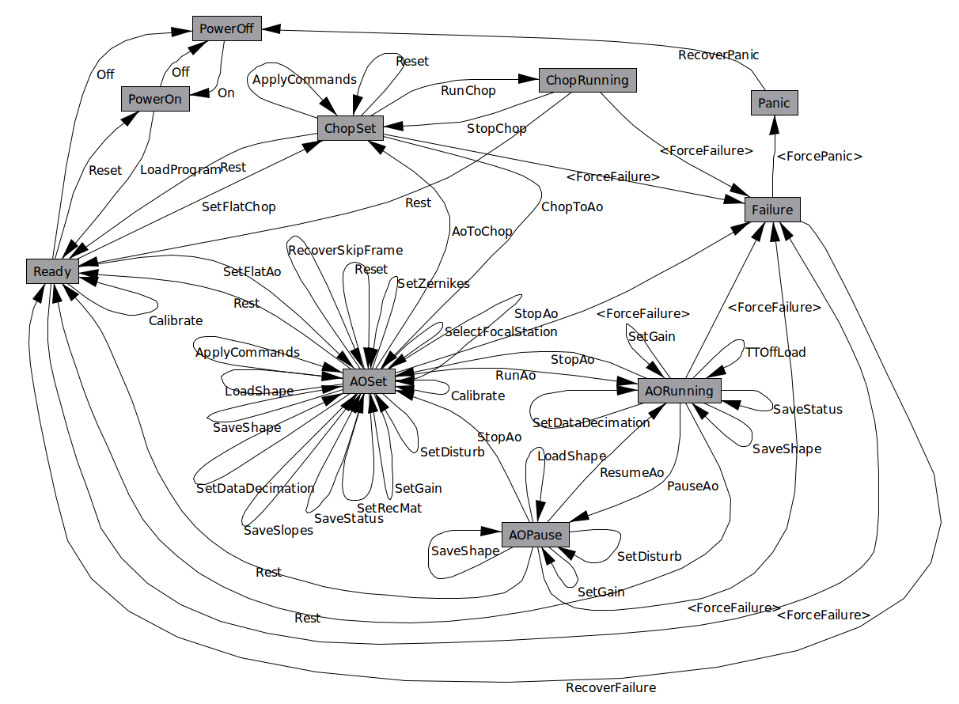
Figure 2 - lbt672 Finite State Machine. Note the all the Chopping features and events have not been implemented.

IDL procedure interface for actions
In this section the IDL interface procedures for actions are described. All the procedures are in the directory “/adsec_lib/adsec_scripts”. These procedures describe the communications between AO-Supervisor and the on-board software (BCU, DSP) that are needed to fulfill a required action.

fsm_power_on
Function for the passage from the Power off state to Power on state.
Power-on-Program event: [Power-on-Program action]
                - Adaptive Secondary Main Power Supplies (MPSs) are switched on.
Category: Supervisor IDL function.
Calling Sequence: err = fsm_power_on()
Inputs: None.
Keyword parameters: None.
Outputs: err: Error code.

fsm_load_program
Function for the passage from the Power-on state to the Rest state. In the Power-on state the LBT672 crates have power. The BCU, SIGGEN, DSP boards and Power Backplane firmware has correctly bootstrapped. HSK diagnostic is running. The shell is pushed against the reference plate by the bias magnets.
LoadProgram event: [LoadProgram action]
              - Communications with DSP is tested;
              - DSP program is uploaded;
              - DSP memories are initialized;
              - The default configuration is loaded;
              - DSP program is started;
              - Communications with DSP is tested again;
              - ASM FST is started;
              - The functionality of coils, current drives and capacitive sensor is checked;
              - Dust contamination is tested;
Category: Supervisor IDL function.
Calling Sequence: err = fsm_load_program()
Inputs: None.
Keyword parameters: AUTO: if set the load program is done automatically.
Outputs: err: Error code.

fsm_reset
Function for the passage from the Rest state to the PowerOn state.
Reset event: [Reset action]
                - Reset all crates.

Category: Supervisor IDL function.
Calling Sequence: err = fsm_reset()
Inputs: None.
Keyword parameters: None.
Outputs: err: Error code.

fsm_power_off
Function for the passage from the Power on state to Power off state.
PowerOff event: [PowerOff action]
                - Adaptive Secondary Main Power Supplies (MPSs) are switched off.
Category: Supervisor IDL function.
Calling Sequence: err = fsm_power_off()
Inputs: None.
Keyword parameters: None.
Outputs: err: Error code.

fsm_set_flat
Function for the passage from the Rest state to AOSet state. In the Rest state the DSP program is uploaded and running, diagnostic tests have been made, ASM FST and HSK and AHSK are running. The shell is pushed against reference plate by the bias magnet and coils are disabled (see 3.5.1 for details). At the end of this procedure the ASM is in AOSet state.
Set&Flat event: [Set&Flat action]
              - Clears history of currents, command, modes, and the like on DSP;
              - Enables coils;
              - Reads the final Set state;
              - Reload the feed forward matrix.
              - Sets the mirror to the relative set configuration;
              - Applies the relative flattening position;
              - Ramps the derivative and proportional gain for the chosen set;
              - Initializes the optical loop;
              - Sets the last parameters for a RTR test.
              - Update the new state.
Category: Supervisor IDL function.
Calling Sequence: err = fsm_set_flat()
Inputs: None.
Keyword parameters: FF : Set only the proportional gain for feed forward matrix calibration.
NO_FLAT : Skip the default flat application.
Outputs: err : Error code.

fsm_load_shape
Function for the update of the current shape hold by the ASM in the AOSet state. The configuration loaded is a flattening command. The reconfiguration of a state is considered as a switch of states with same start and final state.
LoadShape event: [LoadShape action];
              - Sets the new commands to the mirror corresponding to a pre-calibrated shape.
Category: Supervisor IDL function.
Calling Sequence: err = fsm_load_shape()
Inputs: Shape file. If not provided, the default flat is loaded.
Keyword parameters: MARK_AS_DEFAULT : The new shape loaded will be se as default shape.
Outputs: err : Error code

fsm_load_rec
Function for the update of the reconstructor paramenters in the AOSet state. The reconfiguration of a state is considered as a switch of states with same start and final state.
LoadRec event: [LoadRec action];
              - Sets the new parameters for a RTR test.
Category: Supervisor IDL function.
Calling Sequence: err = fsm_load_rec()
Inputs: None.
Keyword parameters: REC_MAT_A_FILE : File name of the .fits reconstructor matrix block memory A.
REC_MAT_B_FILE : File name of the .fits reconstructor matrix block memory B.
A_DELAY_FILE : File name of the .fits mode delay matrix.
B_DELAY_A_FILE : File name of the .fits slope delay matrix block memory A.
B_DELAY_B_FILE : File name of the .fits slope delay matrix block memory B.
M2C_FILE : File name of the .fits modes to command matrix.
G_GAIN_A_FILE : File name of the .fits loop optical gain matrix block memory A.
G_GAIN_B_FILE : File name of the .fits loop optical gain matrix block memory B.
Outputs: err : Error code.

fsm_apply_cmd
Function to modify the current shape of the ASM in the AOSet state. The reconfiguration of a state is considered as a switch of states with same start and final state.
ApplyCmd event: [ApplyCmd action];
              - Sets the new commands to the mirror actuators.
Category: Supervisor IDL function.
Calling Sequence: err = fsm_apply_cmd()
Inputs: Command vector. The new commands are delta respect to the last flat shape loaded.
Keyword parameters: DELTA : The new commands are applied respect to the current mirror shape.
Outputs: err : Error code

fsm_correct_modes
Function to modify the current shape of the ASM in the AOSet state. The reconfiguration of a state is considered as a switch of states with same start and final state.
CorrectModes event: [CorrectModes action];
              - Apply new Zernike mode to the mirror.
Category: Supervisor IDL function.
Calling Sequence: err = fsm_correct_modes()
Inputs: Coefficient vector. The new modes are delta respect to the last flat shape loaded.
Keyword parameters: DELTA : The new commands are applied respect to the current mirror shape.
Outputs: err : Error code

fsm_run_ao
Function for the passage from the AOSet state to the AORunning state. The ASM starts to accept the commands from the wavefront sensor unit and follows the commands.
RunAO event: [RunAO action];
              - Configure the ASM for the AO loop start.
Category: Supervisor IDL function.
Calling Sequence: err = fsm_run_ao()
Inputs: FREQ: frequency of optical loop
DEC: decimation factor of diagnostic frames
OVS_P: oversampling period of oversampling frames
Keyword parameters: DELTA : The new commands are applied respect to the current mirror shape.
Outputs: err : Error code

fsm_pause_ao
Function for the passage from the RunningAO state to the AOPause state. The ASM temporary stop to accept the commands from the wavefront sensor unit and keeps the last commanded position.
PauseAO event: [PauseAO action];
              - Configure the ASM to temporary stop the optical loop.
Category: Supervisor IDL function.
Calling Sequence: err = fsm_pause_ao()
Inputs: None.
Keyword parameters: None.
Outputs: err : Error code

fsm_resume_ao
Function for the passage from the AOPause state to the AORunning state. The ASM start again to accept the commands from the wavefront sensor unit.
ResumeAO event: [ResumeAO action];
              - Configure the ASM to restore the optical loop.
Category: Supervisor IDL function.
Calling Sequence: err = fsm_resume_ao()
Inputs: None.
Keyword parameters: None.
Outputs: err : Error code

fsm_stop_ao
Function for the passage from the RunningAO state to the AOSet state and corresponds to a permanent opening of the optical loop. The default behavior is to load the last flat shape.
StopAO event: [StopAO action];
              - Stop the AO loop and go to flat position.
Category: Supervisor IDL function.
Calling Sequence: err = fsm_stop_ao()
Inputs: None.
Keyword parameters: HOLD: instead of restore the last loaded flat commands, the last shape applied to the ASM is freezed
Outputs: err : Error code

fsm_rest
Function for the passage from the AOSet state to the Rest state. In the AOSet state the mirror shell is set as floating. All ASM FST and HSK and AHSK diagnostics are running. The internal integrator of control forces is active and triggered by an internal clock. In the Rest state the shell is pushed against the reference plate by the bias magnets. Coils are disabled. All the diagnostics are still running.
Rest event: [Rest action]
            - The shell is sucked against reference plate ;
            - Coils are disabled;
            - Parameters and thresholds of FST are updated;
            - Tests that all is in rip.
Category: Supervisor IDL function.
Calling Sequence: err = fsm_rip()
Inputs: None.
Keyword parameters: None.
Outputs: err : Error code.

fsm_fault_recovery
Script to recover the ASM from a fault event. Clear DACs, filters, delay lines and disable the coils. Reload all DSP code.
Category: Supervisor IDL function.
Calling Sequence: err = fsm_fault_recovery()
Inputs: None.
Keyword parameters: None.
Outputs: err : Error code.

fsm_set_gain
Script to set a new optical loop gain in the running AO state.
Category: Supervisor IDL function.
Calling Sequence: err = fsm_set_gain(G_GAIN_A_FILE = g_gain_a_file, G_GAIN_B_FILE = g_gain_b_file)
Inputs: None.
Keyword parameters:
G_GAIN_A_FILE : File name of the .fits loop optical gain matrix to write in the A memory block.
G_GAIN_B_FILE : File name of the .fits loop optical gain matrix to write in the B memory block.
Outputs: err : Error code.

References

[Ref 1] Biasi R, Andrighettoni M, Veronese D, Adaptive Secondary Control System – Design Report, CAN 640a006b, 2003

